NAME of SETTING

Collective Worship
Policy

‘Worship the LORD with gladness; come before him with joyful songs’
Psalm 100

Portsmouth and Winchester Diocesan Board of Education

Introduction
This policy is an agreed statement of the values and aims of collective worship at NAME of SETTING. It has been prepared by the governors and headteacher with assistance from other staff and diocesan advisers. Collective worship is valued as a central aspect of the life of our church school, through which children grow spiritually, emotionally, morally and culturally.

Legal status of collective worship
In a Church of England school, worship must be in line with the trust deed of the school and will reflect the traditions of the Church of England, i.e. the Anglican tradition.

The right of withdrawal
Parents have a legal right to withdraw their child from acts of worship. We ask for this to be discussed with the headteacher so the exact nature of worship is understood by the parents before this becomes a permanent arrangement; alternative activities can be provided for worship time in consultation with parents. Please be aware that this does not mean that the children will be exempt from the Christian ethos of the setting which underpins our teaching, learning and relationships.

Worship in our school should:

As worship:
- Be at a level to enable children and adults to explore their own understanding of God within a Christian framework
- Explain and promote the core Christian values of the setting
- Have Integrity as acts of Anglican worship whilst being invitational, inclusive and inspirational
- Be based on Biblical text or themes
- Be central in importance to the life of our school community, which is part of a wider community that embraces the whole world
- Mark the seasons and festivals of the Christian year
- Develop understanding of Anglican traditions such as the lighting of a candle or use of a cross

For people:
- Develop personal spirituality within the setting community through a range of experiences including individual and collective prayer
- Celebrate the God given gifts and talents of individuals
- Make a significant contribution to the overall spiritual, moral, social and cultural development of members of the school community
- Consider the beliefs and values of others, especially those within the setting community

To comply:
- Reflect any trust deed of the setting
- Be clearly outlined in the setting prospectus and documentation
- Involve children and adults in planning, leading and evaluating collective worship eg through acting our stories
- Be monitored and evaluated by foundation governors for the impact it has on the school community

Aims of our worship
- To promote the joy of worship as engaging, inspiring and transformative
- To develop spirituality, morality, social and cultural values
- Sometimes to provide a peaceful environment enabling stillness, reflection and prayer
- Sometimes to be noisy and joyous with singing, music, dance, drama, gymnastics etc
- To give an opportunity to experience faith as revealed in the Bible
- To understand, celebrate and develop children’s knowledge of Christian beliefs, celebrations, traditions and religious festivals in the Anglican Church’s year
- Facilitate a deeper understanding of the Christian story narrative, from creation to the present day
- To appreciate that people, cultures and beliefs differ and to demonstrate respect, tolerance and generosity towards them
- To develop young children’s sense of self-worth and to provide opportunities to celebrate achievements.
- To develop a caring attitude to others and a sense of community and loyalty
- To provide opportunities for children to plan, lead, contribute to, monitor and evaluate collective worship
- To invite clergy of the parish, other lay members of the parish and other Christian leaders in the community [as are acceptable to the parish church] to lead worship weekly

How we achieve our aims
We aim to promote collective acts of worship, which are rich, meaningful experiences that are appropriate and significant to the pupil’s needs, age, development and interest by:

- Creating a sense of occasion and reverence
- Providing opportunities that develop pupil’s awareness of what is beautiful, good, wonderful, awesome and puzzling in life experience
- Arranging worship at different places when possible, different times with different people and groupings, involving all members of the setting community at some time
- Planning and linking themes which focus on a particular idea/concept, i.e. the liturgical year; festivals and celebrations, our Christian values
- Using a wide range of resources, artefacts (from religious and secular sources), music, art, drama and external visitors to engage children’s interest
- Encouraging children to participate and experience different styles of worship, e.g. prayer, praise, silence, rituals, and become familiar with the language of worship, Biblical readings and liturgy
- Providing opportunities for children and adults to reflect, contemplate their own thoughts, feelings and beliefs
- Using the centrality of prayer – personal silent prayer, personal shared prayers, collective prayers, writing prayers; all prayer will be invitational
- Involving young children and members of the wider community to participate in collective worship and activities within the parish
- Presenting and creating displays that promote and enhance spiritual ideas, thoughts and questions

Central attributes of an act of worship
The setting will endeavour to fulfil the following ‘central attributes’ of worship:
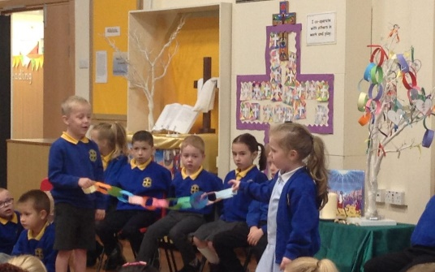
Gathering Making worship a special time of the day
Engaging Using the best available techniques to stimulate interest in the content
Responding Ensuring there is time and opportunity for individual, group reflection and thought, so those attending can respond in a variety of ways
Sending Summarising the worship in a meaningful short message used to create an opportunity for those attending to implement the ideas covered and to conclude the worship

Collective worship should be planned systematically, so that there is continuity, variety and clear focus on Christian beliefs and festivals. Worship is led by a variety of people that include school staff, young children, representatives from the parish church, members of different faith communities and members of the local community.

The centrality of prayer
During the collective worship there will be a time for response and reflection, to ponder on a question, statement or thought. This may also be reflected in an invitational prayer, offered spontaneously by a child or adult, read out or recited. This prayer can be displayed and used in class and setting reflective areas so that:
- Children understand the nature and purpose of prayer
- Children understand the part prayer may play in their lives and the life of the setting community
- Prayer contributes to the spiritual development of individuals and the whole setting community
- There will also be appropriate opportunities for prayer and other worship activities, including reflection, outside of collective worship

The school has a ‘reflective area’ to engage and promote individual young children and adults, as well as designated special spaces in classrooms or shared areas.

Planning and Organisation

Planning
Collective worship is planned systematically, so there is continuity, variety and clear focus on Christian beliefs and festivals. Worship is led by a variety of people that include school staff, pupils, governors, representatives from the parish church, members of different faith communities and members of the local community.

Organisation
Monday
Tuesday
Wednesday
Thursday
Friday

Resources
The setting has resources available to support collective worship and these are stored in ________, this includes artefacts and music resources. Electronic resources can be found on the school network at:_________.

Communication
The school will communicate with parents our collective worship themes via newsletters and display boards.

Parental involvement
Parents are actively encouraged to participate in collective acts of worship when possible.

Responsibilities
The normal expectation within our church school is for all staff to view collective worship as an important part of their own well-being and spiritual development as human beings. The school will endeavour to timetable staff so all have an opportunity to attend regularly.
At interview all applicants are informed that the setting holds acts of collective worship that promote the Christian ethos and values of the school. The normal expectation will be that staff will participate in and lead collective worship. The school welcomes offers from any member of staff who feels confident to lead worship.
NAME of PERSON is responsible for co-ordinating the programme of induction and training for staff.
NAME of PERSON is responsible for planning and organising collective worship.

Monitoring and evaluation
Monitoring and evaluation of collective acts of worship, is undertaken by young children and staff. All who deliver worship will be observed on a termly basis. This process supports the school’s self-evaluation and staff development and appraisal. All leaders of collective worship are asked to evaluate continuously, reflect after every worship, to develop and improve their practice.

Review
This policy should be reviewed annually.
References to ‘parish’ refer to the local parish church to which the school is linked.

Appendices
APPENDIX 1 - SIAMS grade descriptors for collective worship
APPENDIX 2 - 1a Collective worship observation form and 1b A practical guide to evaluating collective worship
APPENDIX 3 - Liturgical Colours and seasons of the Christian year

APPENDIX 1 – SIAMS Grade Descriptors for Collective Worship of

Strand 6: The Impact of Collective Worship

In a Church school collective worship should be inclusive, invitational and inspiring.

In a Good Church school which enables pupils and adults to flourish:
Worship is invitational offering everyone the opportunity to engage whilst allowing the freedom for those of other faiths and none to be present with integrity. All those who wish to be so are actively engaged in worship. Prayer is a natural and valued part of the culture of the school. It is not compulsory or forced. All those who wish to do so will have regular opportunities to pray and reflect. Pupils talk about the value of prayer and reflection both in formal and informal contexts and how being still and reflective in their own lives can be helpful. As appropriate to context, pupils speak of their personal use of prayer and reflection. Pupils recognise that worship provides meaningful opportunities to contribute to their spiritual development.

Statutory obligations are met in context.

Worship is creative and pupils talk about how it often inspires them to action. It has variety, for example, involving music and liturgy, silence, story and reflection and, where appropriate, the Eucharist. Most staff and pupils talk about how worship causes them to reflect on their behaviour, values and attitudes. Worship ensures pupils develop an appreciation of the variety of elements and styles found in the diversity of liturgical and other traditions of the worldwide Anglican/Methodist Church and its diversity of expression within the UK. Worship provokes thoughtful and respectful responses from pupils. They are aware of the central importance of the Eucharist/Communion to Christian worship.

Planning for collective worship ensures that pupils have opportunities to encounter the teachings of Jesus and explore the relevance of his teaching in today’s world. Pupils talk about the meaning of the different elements of Christian worship including belief in the trinitarian nature of God.

An effective shared approach to planning allows appropriate opportunities for pupils to gather, engage and respond. The planning, monitoring and evaluation of collective worship involves a range of members of the community. Pupils are actively involved in this process, often taking a consultative role. Most leaders of worship, including clergy, have access to regular training.

The local church community is regularly involved in collective worship, providing practical support and encouragement.

Requires Improvement: it is not yet Good.

Excellent: it is better than Good. For example:
- The school community recognises and values worship as the heartbeat of the school. Pupils
and adults talk with enthusiasm about worship and explain how it influences their lives, both in
and out of school.
- School leaders work proactively with the local church community or diocese who provide
innovative and appropriate support for collective worship. Pupils take a considerable lead in
the development of worship within the school. Staff are well supported to lead engaging tutor
group and classroom worship.
- Pupils articulate an informed and evaluative understanding of the value and use of prayer and
reflection. There are varied and interactive prayer and reflection activities on offer to all pupils
which they find helpful and supportive.
- Pupils are enabled to engage with the Eucharist in creative and innovative ways, and this
ensures a range of age and context appropriate opportunities for pupils to explore the
Eucharist in ways that respect the integrity of the pupils.
APPENDIX 2 – 1a Collective worship observation form

Setting ___________________________________________________________________________________

Leader: ____________________________________ Observer: ____________________________________

Worship Theme: _____________________________ Time Allocation: _________________ minutes

Collective worship in Church of England Settings should at its simplest create a time and space where we can come closer to God and God can come closer to us.

CRITERIA | ASPECT | COMMENT
Central Attribute 1  Gathering | Is there a real sense of a very special time in the day?  Immediate impact, relevant, welcoming, stimulates interest or dull, uninteresting, lacks focus.
Central attribute 2  Engaging | Does the worship leader capture the attention of the children and staff so they become actively engaged in the content?  Excellent - well expressed, stimulating or poor communicator  Convincing, enthusiastic, warm or lack of rapport.
Central attribute 3  Responding | Does the leader allow for a response from the children and adults – whether active or passive, noisy or quiet?
Central attribute 4  Sending | Does the leader send us out with a clear “thought for the day” something that changes our behaviour in some way?  Clear summary, learners given opportunity to reflect or unclear what the message was.
In addition
Content | Clear Christian / Biblical content and teaching.  Woolly, lack of structure, largely secular.
Summary

APPENDIX 2 – 1a Observation form pointers for consideration - NB not a check list.
Collective worship in Church of England Settings should at its simplest create a time and space where we can come closer to God and God can come closer to us.
Gathering | Music (entry/exit) | appropriate / random, linked to theme, creates atmosphere, delivers a message
 | Welcome | whether greetings exchanged and introduction made
 | Atmosphere | extent to which act of worship is portrayed as special and important
Engaging | Focus | table, cloth, Bible, cross, candle, artefacts ICT / Visual / drama provides appropriate, linked relevant visual/factual information
 | Awe and Wonder | sense given of marvel of world / creation
 | Conviction | extent to which message is clear and compelling or words lack power and appear as paying lip service
Responding | Participation | extent to which learners involved in responding, partner talk, opportunities for some to participate directly
 | Singing | whether there was appropriate hymn / song, quality, enthusiasm of participation
 | Reflection | learners given time to pause and reflect
 | Prayers | extent to which prayers are appropriate and learner friendly, whether learners are invited to respond
Sending | Dismissal | whether the person takes charge, smiles, engages with some learners, says ‘thank you’
Other aspects | Distinctively Anglican | clear reference is made to the Bible and Anglican Christian teaching and belief e.g. the Trinity - God, Jesus and Holy Spirit
 | Inclusive | the worship reflects the multi faith / cultural nature of the world and feels inclusive to those of other and no faith
 | Dynamism & Theatricality | was it a performance rather than an act of worship
 | Open or Closed | does the leader give room for the children to build their own meanings / connections / links or are they told what to think?
 | Age Appropriateness | are the language, concepts, ideas appropriate? Is it meaningful for the youngest yet appropriate for the oldest?

APPENDIX 3

Liturgical Colours and seasons of the Christian year

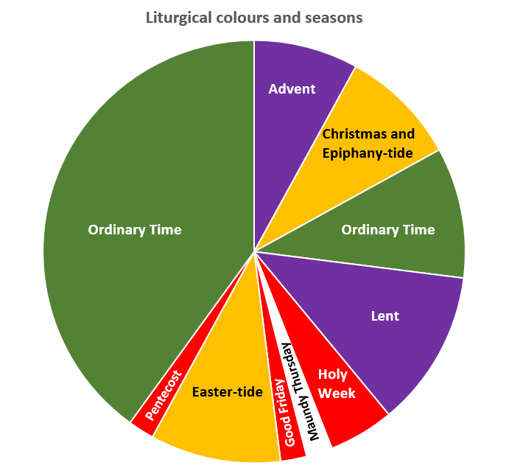

Season | Liturgical Colour | Description
Advent | Purple | The period covering the four Sundays before the 25th December:  Period of preparation for Christmas.
Christmas-tide | White or Gold | 25th December to 2nd February
Gap Between | Green | Gap of Green until Tuesday before Ash Wednesday
Lent | Purple | The 40 days of preparation for Easter
Maundy Thursday | White or Gold | The Last Supper
Good Friday | Red | The Crucifixion
Easter-tide | White or Gold | Easter Day until Pentecost
Pentecost | Red | 50 Days after Easter (lasts a week)
The Rest of the Year | Green | From Pentecost to Advent
Meaning of the colours | Purple | Penitence, preparation
 | White or Gold | Joy, purity, innocence, Saints who are not martyrs
 | Red | Fire & Blood, therefore Holy Spirit and Martyrdom
 | Green | Everything else
In some places | Blue | The Blessed Virgin Mary
 | Pink | Mothering Sunday (4th in Lent) and 3rd in Advent
There are different versions of the colours used.
Please consult your parish for the colours used locally.

