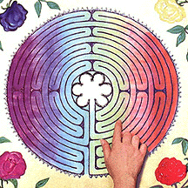
Labyrinth Prayers

Teacher Guidance

Context: The labyrinth is an ancient symbol which was
incorporated into the Christian tradition of prayer from the
earliest centuries. It is not a ‘puzzle’ but a way of focussing
our inner journey in order to sustain our outward prayers
and actions.

You will need: A printed labyrinth for each child such as the one on the following page. Simpler versions for younger children are freely available online.

Explain to the children: What I have given you is a labyrinth, not a maze – a maze is a puzzle but a labyrinth only has one path. You can often find large labyrinths on the ground for walking around (there is one on the top of St Catherine’s hill in Winchester) but we are going to trace this one with our fingers to help us with our prayers.

1. Start by placing your finger at the entrance to the labyrinth. Think about the things that make you sad in your life and the things that make you happy in your life.

2. Begin to trace the path toward the centre and as you go along, think about the things in your life that you can do something about and the things that you can’t do anything about.

3. When you arrive in the centre, reflect on the people, places and choices in your life. Is there anything that you would like to pray about?

4. Trace the path back outward, think about what God is saying to you about your daily life. Is there anything that you want to do differently?

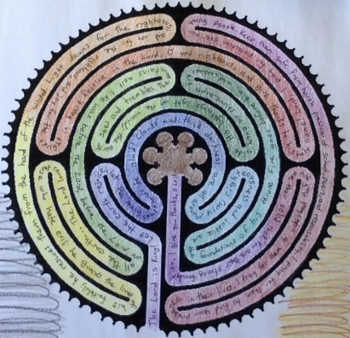
You may like to give the children the opportunity to decorate their labyrinth so that they can keep it and use it again. You could even laminate these if time/budget allowed.

