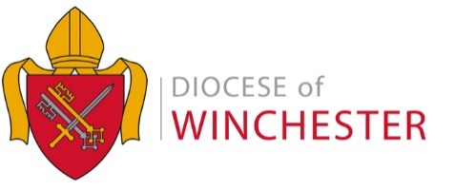

DIRECT DEBIT PAYMENTS SCHEDULE – 2023
Return to finance@winchester.anglican.org

Parish:………………………………… Deanery: …………………………………

Please confirm by which option we should collect your 2023 Common Mission Fund (CMF) contribution

  - 10 equal payments

  - 12 equal payments

  - Payments as outlined in the schedule below

DATE | £
January
February
March
April
May
June
July
August
September
October
November
December

Total

Payments are taken on the 25th of the month (or on the next working day).

Name: ………………………..………………
(Block Capitals)

Treasurer’s Signature: ……………………………

Date: ………………………………

