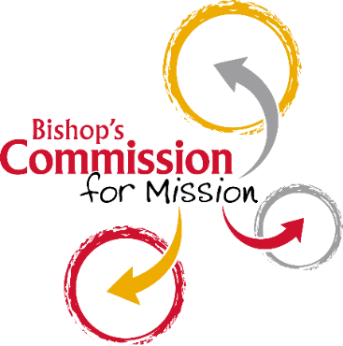

*…. equipping you to share God’s life*

**Bishop’s Commission for Mission**

**Application Form**

**Please indicate which BCM stream you are applying for:**

|  |  |  |  |
| --- | --- | --- | --- |
| Beyond Church Walls |  | Creation Care |  |
| Pastoral |  | Worship |  |

|  |  |  |
| --- | --- | --- |
| Surname |  | Title |
| Forename(s) |  | Date of Birth |

|  |
| --- |
| Address |
| Postcode |

|  |  |
| --- | --- |
| Mobile | Tel Home |
| Email |  |

|  |
| --- |
| Benefice or Parish Church you usually attend |

**CHURCH INVOLVEMENT AND EXPERIENCE**

Tell us about what you do/have done in the life of the church relevant to the BCM you are applying for.

|  |
| --- |
|  |

**SELF ASSESSMENT**

How do you hope this training will help you in your ministry?

|  |
| --- |
|  |

**ADDITIONAL NEEDS**

Please give details of any special circumstances or support needed to participate in this training.

|  |
| --- |
|  |

**FOR THE INCUMBENT TO COMPLETE**

**INCUMBENT**

*In the event of a parish vacancy please could this section be completed by either a supervising member of the clergy within the benefice or the Area Dean*

|  |
| --- |
| Name  Email |

* I confirm the PCC have agreed to support this candidate taking the BCM programme.
* I confirm that, in consultation with the Parish Safeguarding Officer, there are no safeguarding concerns known to me in relation to this applicant.
* I confirm I am happy for this person to go forward for BCM training.
* I confirm the information on this form is correct as far as I am aware.

**Signature of incumbent:**

**Date:**

**My commitment to this programme.**

Please read, tick and sign your agreement.

I intend to be present and participate in all sessions, as I recognise this training is

not just about my learning and formation, but about the other people on the programme

I am responsible for my ongoing learning and commit to attending the annual

follow-up meeting (usually held in spring of each year)

I realise there is a cost of £60 for this programme which should be covered by my PCC.

(See note below *)

I understand that a new enhanced DBS will be required for this role. (Please note this cannot be

completed until the end of the BCM programme).

I recognise that I will need to complete Basic, Foundation and Leadership safeguarding training modules in order to be commissioned. Basic and Foundation can be taken online. We will advise you about accessing leadership level during your training.

I will produce a reflection on how the training has shaped me for ministry at the end of the

programme. (More details will be given during the programme).

I understand I have to meet all the criteria to be commissioned. I will attend the Lay Ministries

Service in October to be formally commissioned (please invite your incumbent and parishioners to attend).

**Signed (applicant):** **Date:**

DATA PROTECTION AND CONFIDENTIALITY

Winchester Diocesan Board of Finance will need to hold some personal information (“personal data”) about BCM participants, including name, address, email and contact telephone number.  This information will need to be kept after completion of the programme so that the School of Mission can invite participants to ongoing BCM training events and advise them when re-commissioning is due.  If your contact details change please remember to let us know.

All data will be stored in accordance with our privacy notice which can be found on our website : <https://www.winchester.anglican.org/privacy/>

If you have any questions about any of this please contact our BCM administrator, **Wendy Atkinson** who is there to help you. We look forward to welcoming you onto one of the BCM programme streams.

**This completed form should be returned electronically to**

**Wendy Atkinson**

[wendy.atkinson@winchester.anglican.org](mailto:wendy.atkinson@winchester.anglican.org),

*Please ask your church treasurer to make payment by bank transfer and to email Wendy to let her know when the payment has been made. In the current situation we cannot accept cash or cheques.

There may be discretion in cases of financial difficulty. Please contact Wendy for more information.

*If paying electronically please use the bank details below, quoting the reference DMD5722 on the transfer and the benefice it has come from:*

Bank: NatWest PLC

Account No:00342564

Sort Code: 55-81-26