Curacy
Reporting Form
Form 1:

Name of Assistant Curate: | Click or tap here to enter text.
Benefice: | Click or tap here to enter text.
Focus of Ministry: | Choose an item.
Dates of Ordinations: | Deaconing: Click or tap to enter a date.  Priesting: Click or tap to enter a date.
Name of Training Incumbent: | Click or tap here to enter text.
Dates of Reports: | Year 1: Click or tap to enter a date.  Interim: Click or tap to enter a date.  Final: Click or tap to enter a date.
Has the Core Skills Checklist been reviewed and updated: | Year 1: Choose an item.  Interim: Choose an item.  Final: Choose an item.
Dates of Review of Ministry Specification and Curacy Development Plan: | Year 1: Click or tap to enter a date.  Interim: Click or tap to enter a date.  Final: Click or tap to enter a date.
Dates of Safeguarding Training most recently completed: | C2 C3 Leadership: Click or tap to enter a date.  Domestic Abuse Awareness: Click or tap to enter a date.  Safer Recruitment and People Management: Click or tap to enter a date.
Number of supervision sessions held/attended during year: | Year 1: Click or tap here to enter text.  Year 2: Click or tap here to enter text.  Year 3: Click or tap here to enter text.
Number of days off completely missed/not made up by other time off in lieu during each year: | Year 1: Click or tap here to enter text.  Year 2: Click or tap here to enter text.  Year 3: Click or tap here to enter text.
Regular Support from Spiritual Director / Soul Friend in place: | Year 1: Choose an item.  Year 2: Choose an item.  Year 3: Choose an item.

Producing your Annual Report:
At the end of each year, curates and training incumbents are asked to complete a report on the curate’s progress jointly. This gives an opportunity to reflect on:
- The seven formation qualities over the four domains;
- Areas of ministry and leadership that have been a significant part of the curate’s ministry in the past year that can be celebrated;
- How the curate is inhabiting the seven formational qualities, and how this has developed over the year;
- Areas of ministry and leadership which will be developed and prioritized in the coming year (to be documented on the curacy development plan- form 3);
This report plays a crucial role in monitoring development across the whole of a curacy, and it is vital that time is taken to talk through each element together. This is not an exercise to do in isolation.
The report is to be completed in two parts, with further explanation below.
Part One asks for conversation using the top-level qualities grid to give an informal colour coding to each of the qualities, enabling you to see areas where there is lots of evidence of the quality being inhabited and areas where this is less so.
Part Two builds upon these conversations, asking for written evidence of both ministerial activity and reflection upon the developing picture of each of the qualities, indicating the places for growth in the coming years. It is therefore an important document and is presented to show growth and development across this time.
It is entirely permissible, but in no way required, that appropriate third parties be consulted before the Report is written. The form is designed to be completed electronically, and each section will expand as you type.
When the report is completed, please send a copy electronically to Chris Hill, IME2 Officer, at chris.hill@winchester.anglican.org. Please do contact Chris if you have any questions about the process, and thank you very much for your ministry.
Dates for the submission of Reports:
Start of Curacy: Over the summer, and by the end of September (Qualities Grid, Core Skills and Development Plan)
Year One: in April of Year 1
Interim: at an interim point in curacy, no earlier than the end of Year 2
Final: When the TI deems your training requirements met and ready for the End of Curacy assessment

Part One: The Qualities Grid
You will find editable Word copies of the grid on Moodle.
At the start of curacy, and then annually, you are asked to talk through the top top-level qualities grid taking time together to be aware of the developing way the curate is inhabiting each quality. As you do so, you are asked to assign colours to each square indicating the outcome of your discussion.
You will also find it helpful to look at the more detailed ‘Qualities for Discernment’ document which you can find next to this reporting form on Moodle. These grids articulate the qualities of Church of England ministers which we seek to inhabit over a lifetime progressively. This means that this is not a “tick list” of what you have and have not completed but rather one part of an ongoing conversation between yourself, your Training Incumbent and IME2 Officer about your continuing formational development.
The colours represent:
Inhabiting the quality well with excellent evidence.
Inhabiting the quality comfortably with good evidence.
Developing in this quality.
Requires development with some evidence.
Requires development no evidence currently.

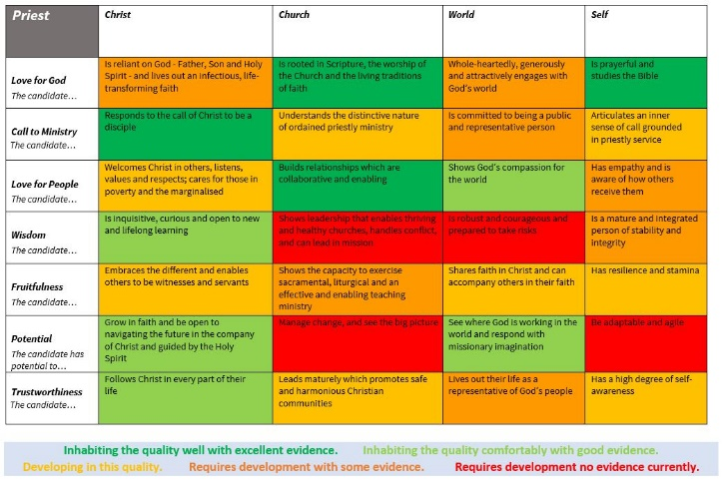
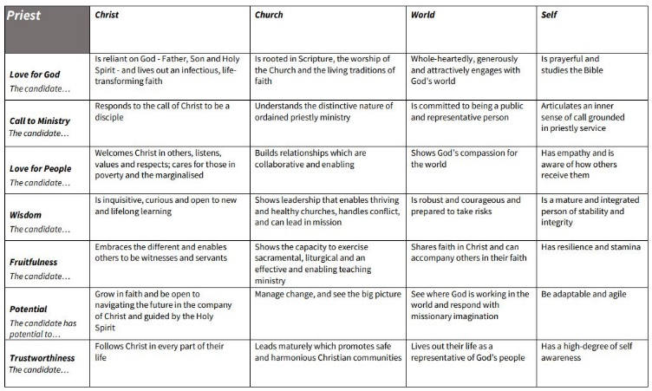
It may be that you do not discuss all of the grids all every time. This is fine but a full picture is expected by the final report. Please know that the aim isn’t to be ‘bright green’ in all areas by the end of curacy, rather the aim is for an honest representation of the curate at the time of each report. The qualities are a useful check in for all throughout ministry and a mix of ‘developing in’ and ‘inhabiting well’ at the end of curacy recognises the need for all to be involved in continuing development throughout our ministry.
Part Two: The Form
The following sections provide the same qualities from the top-level grid with the descriptors over the four domains. This document should grow over the course of your curacy and chart progress as you engage more deeply with each of the seven formation qualities over the four domains. As a result there is no need to repeat information from previous years unless to add emphasis or note a change. Informal feedback to help you will be given after both the Year 1 and Interim reports.

The curacy review is an important opportunity for curate and training incumbent (and any chaplaincy mentor where appropriate) to build on supervision sessions throughout the previous period by reflecting together on its celebrations and challenges and planning together for the year ahead. As well as looking back, the curacy review should look forward and agree specific goals for the following year, which will be documented in the Curacy Development Plan. This curacy review form is therefore a key document to ensure that curates are working towards these qualities, and it forms part of the evidence that enables bishops to sign curates off towards the end of curacy.

Please respond by addressing and evidencing each quality, giving both short specific examples in bullet points to show breadth of coverage and a more reflective exploration of key learning here to show depth of engagement. Where you have not had opportunity to engage deeply yet, it is perfectly fine to simply note this and agree it as part of your learning plan for the following period.
In each section pay careful attention to the four descriptors and the extent to which you embody them, rather than just the overarching quality. There is no need to address all four descriptors equally in any given reporting period but by the end of curacy there must be sufficient evidence of each. The Formation Framework ‘Qualities and Evidences’ document provides a much deeper dive into the kind of evidence you can document, and so this will be a useful resource through out the curacy, and especially at times of writing this report.
The ‘Curate’s Reflections’ on what you have learned as you live out the four descriptors must demonstrate reflective practice, not be purely descriptive. You should focus on transformation, outcomes and insights, more than what you did, and usually engage your feelings and spiritual life. Typically you should identify one or two significant insights or key areas of learning and limit these boxes to 200-500 words. Whereas the bullet points in the previous box point to the breadth of your engagement the reflection boxes should aim for depth.
TIs are encouraged to draw out emerging strengths they have seen in you and to identify areas for growth for the future under each quality, giving specific concrete examples. After reflecting on these together, the TI and Curate should typically choose three or four to be the focus on the agreed Curacy Development Plan- Form 3
If concerns emerge about a curate’s engagement with any of the formation qualities, please speak to the IME2 Officer as soon as possible as there is plenty of help and support available.
It is hoped that during the final End of Curacy Review, the training incumbent will be able to affirm that the curate has engaged with all the relevant formation qualities, achieved competence and confidence in sufficient of the core skills, and is ready for their next post whether as incumbent or associate minister.

Section 1: Love for God

CHRIST:  CHURCH:  WORLD:  SELF: | The curate is reliant on God – Father, Son and Holy Spirit – and lives out an infectious, life-transforming faith.  The curate is rooted in scripture, the worship of the Church and the living traditions of  faith.  The curate whole-heartedly, generously and attractively engages with God’s world.  The curate is prayerful and studies the Bible.
First Year Report | How are you demonstrating the quality Love for God in your ministry so far?  (please give bullet point examples):  Click or tap here to enter text.
Curate (reflections on how you are inhabiting the Quality Love for God):
Click or tap here to enter text.
Training Incumbent (Reflection on the curate’s Strengths and areas for growth relating to inhabiting the quality Love for God):
Click or tap here to enter text.
Interim Report | How are you demonstrating the quality Love for God in your ministry so far?  (please give bullet point examples):  Click or tap here to enter text.
Curate (reflections on how you are inhabiting the Quality Love for God):
Click or tap here to enter text.
Training Incumbent (Reflection on the curate’s Strengths and areas for growth relating to inhabiting the quality Love for God):
Click or tap here to enter text.
Final Report | How are you demonstrating the quality Love for God in your ministry so far?  (please give bullet point examples):  Click or tap here to enter text.
Curate (reflections on how you are inhabiting the Quality Love for God):
Click or tap here to enter text.
Training Incumbent (Reflection on the curate’s Strengths and areas for growth relating to inhabiting the quality Love for God):
Click or tap here to enter text.

Section 2: Call to Ministry

CHRIST:  CHURCH:  WORLD:  SELF: | The curate responds to the call of Christ to be a disciple.  The curate understands the distinctive nature of ordained priestly ministry.  The curate is committed to being a public and representative person.  The curate articulates an inner sense of call grounded in priestly service.
First Year Report | How are you demonstrating the quality Call to Ministry in your ministry so far?  (please give bullet point examples):  Click or tap here to enter text.
Curate (reflections on how you are inhabiting the Quality Call to Ministry):
Click or tap here to enter text.
Training Incumbent (Reflection on the curate’s Strengths and areas for growth relating to inhabiting the quality Call to Ministry):
Click or tap here to enter text.
Interim Report | How are you demonstrating the quality Call to Ministry in your ministry so far?  (please give bullet point examples):  Click or tap here to enter text.
Curate (reflections on how you are inhabiting the Quality Call to Ministry):
Click or tap here to enter text.
Training Incumbent (Reflection on the curate’s Strengths and areas for growth relating to inhabiting the quality Call to Ministry):
Click or tap here to enter text.
Final Report | How are you demonstrating the quality Call to Ministry in your ministry so far?  (please give bullet point examples):  Click or tap here to enter text.
Curate (reflections on how you are inhabiting the Quality Call to Ministry):
Click or tap here to enter text.
Training Incumbent (Reflection on the curate’s Strengths and areas for growth relating to inhabiting the quality Call to Ministry):
Click or tap here to enter text.

Section 3: Love for People

CHRIST:  CHURCH:  WORLD:  SELF: | The curate welcomes Christ in others, listens, values and respects; cares for those in poverty and the marginalized.  The curate builds relationships which are collaborative and enabling.  The curate shows God’s compassion for the world.  The curate has empathy and is aware of how others receive them.
First Year Report | How are you demonstrating the quality Love for People in your ministry so far?  (please give bullet point examples):  Click or tap here to enter text.
Curate (reflections on how you are inhabiting the Quality Love for People):
Click or tap here to enter text.
Training Incumbent (Reflection on the curate’s Strengths and areas for growth relating to inhabiting the quality Love for People):
Click or tap here to enter text.
Interim Report | How are you demonstrating the quality Love for People in your ministry so far?  (please give bullet point examples):  Click or tap here to enter text.
Curate (reflections on how you are inhabiting the Quality Love for People):
Click or tap here to enter text.
Training Incumbent (Reflection on the curate’s Strengths and areas for growth relating to inhabiting the quality Love for People):
Click or tap here to enter text.
Final Report | How are you demonstrating the quality Love for People in your ministry so far?  (please give bullet point examples):  Click or tap here to enter text.
Curate (reflections on how you are inhabiting the Quality Love for People):
Click or tap here to enter text.
Training Incumbent (Reflection on the curate’s Strengths and areas for growth relating to inhabiting the quality Love for People):
Click or tap here to enter text.

Section 4: Wisdom

CHRIST:  CHURCH:  WORLD:  SELF: | The curate is inquisitive, curious and open to new learning.  The curate shows leadership that enables thriving and healthy churches, handles conflict, and can lead in mission.  The curate is robust and courageous and prepared to take risks.  The curate is a mature and integrated person of stability and integrity.
First Year Report | How are you demonstrating the quality Wisdom in your ministry so far?  (please give bullet point examples):  Click or tap here to enter text.
Curate (reflections on how you are inhabiting the Quality Wisdom):
Click or tap here to enter text.
Training Incumbent (Reflection on the curate’s Strengths and areas for growth relating to inhabiting the quality Wisdom):
Click or tap here to enter text.
Interim Report | How are you demonstrating the quality Wisdom in your ministry so far?  (please give bullet point examples):  Click or tap here to enter text.
Curate (reflections on how you are inhabiting the Quality Wisdom):
Click or tap here to enter text.
Training Incumbent (Reflection on the curate’s Strengths and areas for growth relating to inhabiting the quality Wisdom):
Click or tap here to enter text.
Final Report | How are you demonstrating the quality Wisdom in your ministry so far  (please give bullet point examples):  Click or tap here to enter text.
Curate (reflections on how you are inhabiting the Quality Wisdom):
Click or tap here to enter text.
Training Incumbent (Reflection on the curate’s Strengths and areas for growth relating to inhabiting the quality Wisdom):
Click or tap here to enter text.

Section 5: Fruitfulness

CHRIST:  CHURCH:  WORLD:  SELF: | The curate embraces the different and enables others to be witnesses and servants.  The curate shows the capacity to exercise sacramental, liturgical and effective and enabling teaching ministry.  The curate shares faith in Christ and can accompany others in their faith.  The curate has resilience and stamina.
First Year Report | How are you demonstrating the quality Fruitfulness in your ministry so far?  (please give bullet point examples):  Click or tap here to enter text.
Curate (reflections on how you are inhabiting the Fruitfulness):
Click or tap here to enter text.
Training Incumbent (Reflection on the curate’s Strengths and areas for growth relating to inhabiting the quality Fruitfulness):
Click or tap here to enter text.
Interim Report | How are you demonstrating the quality Fruitfulness in your ministry so far?  (please give bullet point examples):  Click or tap here to enter text.
Curate (reflections on how you are inhabiting the Quality Fruitfulness):
Click or tap here to enter text.
Training Incumbent (Reflection on the curate’s Strengths and areas for growth relating to inhabiting the quality Fruitfulness):
Click or tap here to enter text.
Final Report | How are you demonstrating the quality Fruitfulness in your ministry so far  (please give bullet point examples):  Click or tap here to enter text.
Curate (reflections on how you are inhabiting the Quality Fruitfulness):
Click or tap here to enter text.
Training Incumbent (Reflection on the curate’s Strengths and areas for growth relating to inhabiting the quality Fruitfulness):
Click or tap here to enter text.

Section 6: Potential

CHRIST:  CHURCH:  WORLD:  SELF: | The curate has potential to grow in faith and be open to navigating the future in the company of Christ.  The curate has potential to manage change and see the big picture.  The curate has potential to see where God is working in the world and respond with missionary imagination.  The curate has potential to be adaptable and agile.
First Year Report | How are you demonstrating the quality Potential in your ministry so far?  (please give bullet point examples):  Click or tap here to enter text.
Curate (reflections on how you are inhabiting the Potential):
Click or tap here to enter text.
Training Incumbent (Reflection on the curate’s Strengths and areas for growth relating to inhabiting the quality Potential):
Click or tap here to enter text.
Interim Report | How are you demonstrating the quality Potential in your ministry so far?  (please give bullet point examples):  Click or tap here to enter text.
Curate (reflections on how you are inhabiting the Quality Potential):
Click or tap here to enter text.
Training Incumbent (Reflection on the curate’s Strengths and areas for growth relating to inhabiting the quality Potential):
Click or tap here to enter text.
Final Report | How are you demonstrating the quality Potential in your ministry so far  (please give bullet point examples):  Click or tap here to enter text.
Curate (reflections on how you are inhabiting the Quality Potential):
Click or tap here to enter text.
Training Incumbent (Reflection on the curate’s Strengths and areas for growth relating to inhabiting the quality Potential):
Click or tap here to enter text.

Section 7: Trustworthiness

CHRIST:  CHURCH:  WORLD:  SELF: | The curate follows Christ in every part of life.  The curate leads maturely which promotes safe and harmonious Christian communities.  The curate lives out their life as a representative of God’s people.  The curate has a high degree of self-awareness.
First Year Report | How are you demonstrating the quality Trustworthiness in your ministry so far?  (please give bullet point examples):  Click or tap here to enter text.
Curate (reflections on how you are inhabiting the Trustworthiness):
Click or tap here to enter text.
Training Incumbent (Reflection on the curate’s Strengths and areas for growth relating to inhabiting the quality Trustworthiness):
Click or tap here to enter text.
Interim Report | How are you demonstrating the quality Trustworthiness in your ministry so far?  (please give bullet point examples):  Click or tap here to enter text.
Curate (reflections on how you are inhabiting the Quality Trustworthiness):
Click or tap here to enter text.
Training Incumbent (Reflection on the curate’s Strengths and areas for growth relating to inhabiting the quality Trustworthiness):
Click or tap here to enter text.
Final Report | How are you demonstrating the quality Trustworthiness in your ministry so far  (please give bullet point examples):  Click or tap here to enter text.
Curate (reflections on how you are inhabiting the Quality Trustworthiness):
Click or tap here to enter text.
Training Incumbent (Reflection on the curate’s Strengths and areas for growth relating to inhabiting the quality Trustworthiness):
Click or tap here to enter text.

Before submitting this form annually, please PRINT your name, and date below to confirm that you have discussed this together:
First Year | Curate: | Click or tap here to enter text. | Date: Click or tap to enter a date.
 | Training Incumbent | Click or tap here to enter text. | Date: Click or tap to enter a date.
Interim Report | Curate: | Click or tap here to enter text. | Date: Click or tap to enter a date.
 | Training Incumbent | Click or tap here to enter text. | Date: Click or tap to enter a date.
Final Report | Candidate: | Click or tap here to enter text. | Date: Click or tap to enter a date.
 | Training Incumbent | Click or tap here to enter text. | Date: Click or tap to enter a date.

Section 8: END OF CURACY TRAINING INCUMBENT STATEMENT
(To be completed only after the final report, if the Curate is ready to be recommended for sign-off by the Sponsoring Bishop)
Training Incumbent Statement:
I, [TYPE TI NAME HERE] am satisfied that [TYPE CURATE NAME HERE], assistant curate in the parish/benefice of [TYPE BENEFICE NAME HERE] has shown sufficient engagement with, and development against, the national formation qualities for curates. I am happy for them to now move to their next phase of ministry.
Summative Comments:
Please provide an overview of the Curate’s gifts, the general shape of their ministry, and development through curacy. (1-2 pages)
Click or tap here to enter text.

Initial Thoughts on Future Ministry
Please include here any (individual and joint) reflections on the likely future shape of the curate’s ministry (parish, non-parochial, demographic and social context, church tradition) and any significant factors of timing and geography that may limit choice and availability (e.g. children’s schooling, need to be near elderly parents etc).
Click or tap here to enter text.

Name: Click or tap here to enter text.
Date: Click or tap to enter a date.

