
WAYS TO GIVE

God gives us life and blesses us in all sorts of ways. As a sign of our thanks, we offer him our lives, including gifts of our time, our abilities, and our money.

This leaflet helps with the practicalities of financial giving. To find out more about other ways of giving financially for example a one-off gift please contact our Treasurer.

Kindly consider all eligible monetary gifts made from the date of this statement and within the previous four years as Gift Aid donations. Being a UK taxpayer, I acknowledge that if the total Gift Aid claimed on all my donations in a tax year exceeds the income tax and/or capital gains tax I have paid, I am accountable for covering the shortfall.

REGULAR GIVING
Our parish relies on the generosity of its members, and we appreciate everyone who supports our churches, both financially and in other ways. Contributions may vary over time, but every donation, regardless of size, helps our church carry out its inspiring ministries. To establish a standing order, you can fill out the form on the back or utilise the provided bank details to set it up online. For additional guidance, please reach out to our Treasurer.

GIFT AID
If you are a UK taxpayer and eligible to Gift Aid your donation you can increase the value of your donation by 25% at no cost to yourself.
Please complete the form on this page and send it to: The Treasurer, Parish Office, ………………….
Or scan it and email to:

YOUR LEGACY
Imaginative and generous legacies have brought about remarkable changes in our church. Your legacy has the power to motivate future generations long after you're gone. We guarantee that any contribution you make will have a meaningful impact on the church's work and the broader community. For more details, please reach out to our Treasurer...
Full Name:……………………………………………….

Address:…………………………………………………

……………………………………………………………

……………………………………………………………

Postcode:………………………………………………..

Signature:………………………………………………..

1. Please notify the church/PCC if you:
want to cancel this declaration.
change your name or home address no longer pay sufficient tax on your income and/or capital gains.

2. Gift Aid is linked to basic rate tax, currently 20%. If you pay income tax at the higher or additional rate and want to receive the additional tax relief due to you, you must include all your Gift Aid donations on your self-assessment tax return or ask HM Revenue and Customs to adjust your tax code.

Standing Order

To the Manager,
Bank:…………………………………………………….
Branch:………………………………………………….
Account Number:………………………………………
Account Name:…………………………………………
Sort Code:………………………………………………
Please pay to account number …………………… of (Church Name)…………………………………………, Parochial Church Council at (Bank Name)……………..……................................., (Bank Address…………………………………………, Sort Code…………………..,
the sum of £……………………………………………
On the Date of …../…../ 202
and on the same day in each succeeding month/quarter/ year (delete as appropriate).
Name…………………..………………Date……………
Signature………………………………………………...
This form is intended solely for the donor's use and should be presented at your bank for setup. Keep in mind that you can also establish Standing Orders online or via phone, although procedures may differ from one bank to another.
Reasons To Give

There are numerous reasons to contribute, but here are three points to consider.
We give because He first gave. We recognise that God gave his son that all may have life and that all good things come from Him.
We give to continue the good work set before us. Our church cannot function without the generosity of others. By giving you are enabling all the activities that happen across the life of our church to continue.
A step of faith. When we give, we release our possessions and choose to trust more on God's provision for our lives.
May we know the joy of giving as we determine in our hearts how we want to give our time, talents and money.

Sharing Generously

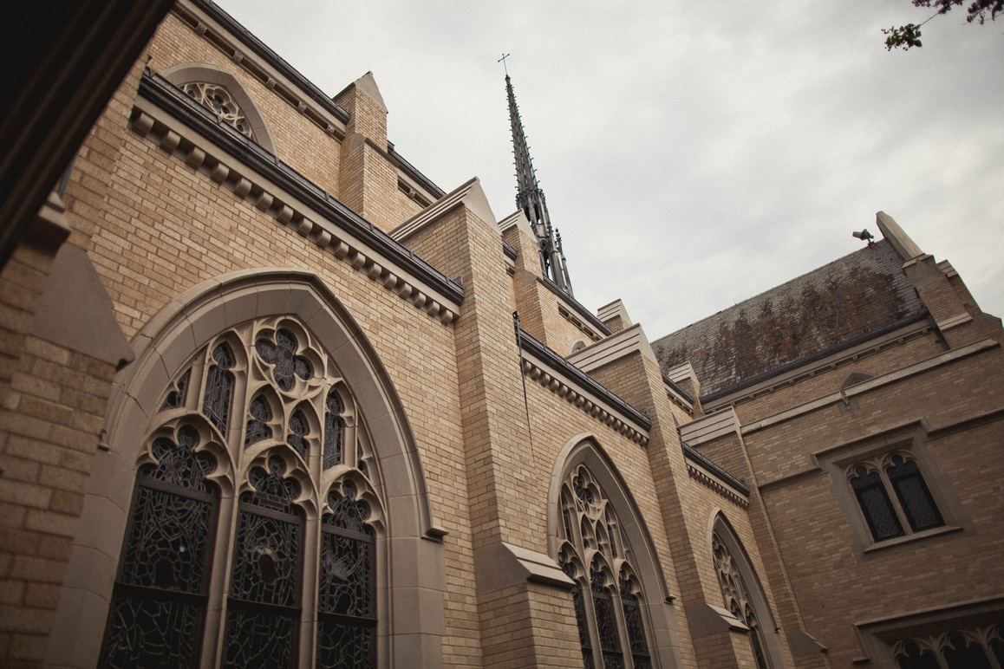

“The earth is the Lord’s, and
everything in it”.
(Psalm 24:1)

