Diocesan synod digest

14th November 2024

This digest is produced to support the communication of information between Diocesan Synod, Deanery Synod and PCCs. Should you have any questions please contact Cathy Laird 01962 737307 or email cathy.laird@winchester.anglican.org .

Items of Business
This meeting marked the first of the new triennium (ends 31st July 2027).

Elections of the Chairs of the Houses
The Revd Angie Smith was elected Chair of the House of Clergy. Mr Alastair Barron was elected Chair of the House of Laity

Elections to Bishop’s Council
The two candidates who stood, The Revd Canon Andrew Micklefield and the Revd Sarah Yetman, were duly elected as clergy representatives.

Eight candidates stood for the four places for elected lay representatives. Each candidate addressed the house of laity with voting closing on the 29th November at 5pm.

Diocesan Racial Justice Strategy DS24/06
Members of the Racial Justice Forum presented to members on the importance of the strategy.

What is racial justice and why do we need it?
Racial justice is the equal treatment of everyone regardless of ethnicity or race. To achieve racial justice, societies must tackle racial prejudice, discrimination, and systems that disproportionately harm some while favoring others. Racial justice reckons with the legacies of discrimination, removes existing barriers to racial equality, and promotes equity.

By reviewing and producing this document we aim to embed a process of eliminating racial disparities and improving outcomes for everyone. It is the intentional and continual practice of changing policies, practices, systems, and structures by prioritizing measurable change in the lives of UKME/GMH people within our communities.

Areas of reform
Honest, Open Conversations
Embedding inclusion and diversity across our diocese at all levels - from every parish to our senior level structures
Education, Training and Advocacy
Seeking to equip communities to act, speak and preach

Theology
Creating change in our schools and Ministry training through theological studies, liturgy, teaching, prayer, word and work
Vocations
Address underrepresentation and overhaul recruitment and voting practices to ensure it is barrier free.

Members approved the following motion by majority with 2 abstentions and 1 vote against.
“This Synod adopts the racial justice strategy as outlined in paper DS24/06”

Financial Response to Budget Challenges DS24/07
The report comes to Synod with the support of The Diocesan Finance Committee and Bishop’s Council. It offers an update on financial performance following the approval of our 3 year financial plan for 2024 to 2026. The paper is offered to not only highlight the immediate financial challenge faced due to low CMF contributions, but to assess this in the wider financial context.

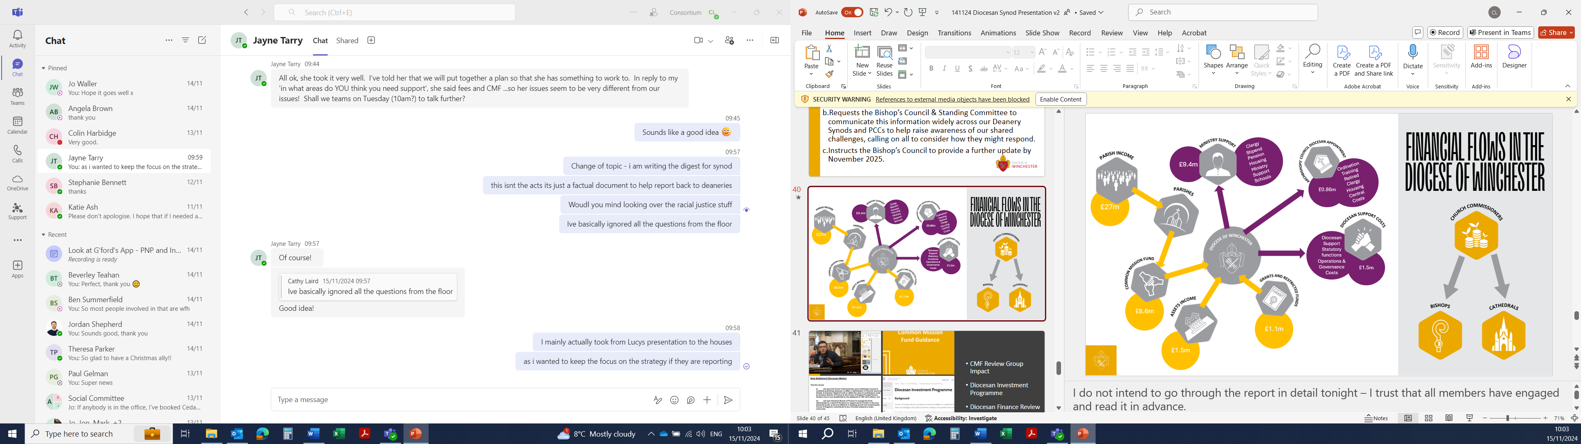
- The 236 PCCs raise a combined total of around £27m a year, predominately funded by giving, parochial fees, trading (hall hire etc) grants and legacies.
- Parishes are then asked to donate £8.6m of this total income (around 32%) to the Common Mission Fund.
- The WDBF receives a further £1.5m from asset income (investments, rental income from vacant properties)
- A further £1.1m is budgeted for from external grants, and income from restricted funds that the WDBF hold.
- Along with around £400k from Parochial fees this leads to total budgeted income of £11.6m.
- The primary expenditure for the WDBF is ministry support – the costs of clergy, houses, stipends, NI, Pensions, training, curates, ministry with schools and dedicated parish support functions in the diocesan team (such as safeguarding). That totals £9.4m a year .
- A further £860k is given to the Archbishops’ Council as part of the Diocesan apportionment to the National Church structures – this includes the costs of training ordinands at theological colleges, support for retired clergy housing, and some national central costs.
- A further £1.5m is then used to fund the remain support costs and statutory functions of the WDBF.
The costs of bishops and cathedral are funded direct by the Church Commissioners and are therefore no cost to the WDBF or our parishes.

The task of Diocesan Synod is to consider how to respond to this challenge.
The Diocesan Finance Committee and the Bishop’s Council have considered this and do not believe that making further cuts to our budget at this stage is right. Balancing the books in the short-term risks causing long term major missional damage.
The Bishop’s Council are also clear that, whilst the current indicators are a concern, there remain many significant unknowns. Taking action before some critical information is available would not be prudent.
In the next 12 months we anticipate know more on the following:
- The impact of the recommendations arising from the CMF Review Group and associated Communications strategy;
- The nature of the next application for funds from the Diocesan Investment Programme through the Strategic Mission & Ministry Council
- The outcome of the national Diocesan Finance Review – exploring options for addressing the combined £63m shortfall across the 42 DBFs.
- The progress of the joint motion from the Dioceses of Hereford & Gloucester seeking to release £2.6bn of Church Commissioners funds back to the Dioceses. The Diocesan Secretary reminded members that the Church Commissioners are a separate charitable entity who are not accountable to General Synod or the Archbishops’ Council.

Members approved the following motion unanimously.
“This Synod:
- Takes note of the challenging financial context as set out in the report from the Bishop’s Council & Standing Committee DS24/07
- Requests the Bishop’s Council & Standing Committee to communicate this information widely across our Deanery Synods and PCCs to help raise awareness of our shared challenges, calling on all to consider how they might respond.
- Instructs the Bishop’s Council to provide a further update by November 2025.”

