**Ways of Planned Giving**

**Make or increase a gift using the Parish Giving Scheme (PGS)**

The PGS is a national scheme that makes giving to a parish straightforward. Where applicable it also claims gift aid for us. There are three ways to start giving using the PGS:

Contact name for a paper application form (contact details overleaf).

Go to the PGS online portal [add the link to your parish]

Alternatively, you can telephone the PGS office on 0333 002 1271 and quote our parish reference [000000000].

**Make or increase a gift by Standing Order**

Please contact your bank and make or vary a Standing Order using the following details:

Bank name, account name, sort code and account number

If you would like to leave a lasting remembrance by leaving a legacy in your will, please contact name or contact theDiocesan Registrars, Batt Broadbent on 01722 432390 / [registry@battbroadbent.co.uk](mailto:registry@battbroadbent.co.uk).

**Gift Aid:** If you pay tax HMRC will add 25% to your gift. If you are setting up a new Standing Order, please contact **name** for a gift aid declaration form.

**[Name of Church]**

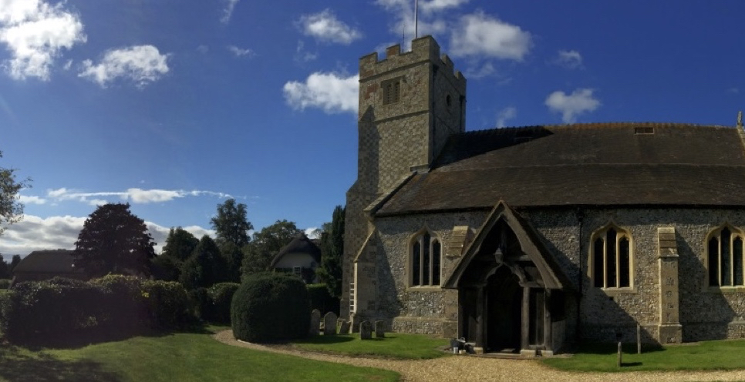

In parishes throughout the Church of England, regular giving, or planned giving, is the bedrock of parish finances – at name of Church planned giving currently provides x% of our income.

We continue to experience financial challenges and so we are asking everyone to consider prayerfully increasing their giving if possible. We know this will not be possible for everyone, but we hope that others will be able to increase their giving.

This year our church needs £xxx per week to pay its way.

*Thank you for all your gifts!*

*However large or small, all are very gratefully received.*

The money we give enables us to make our plans for the future with confidence and secures the future of ministry in this place. For example, it means that we can…

* Pay our fair share to the Diocese to fund clergy here and in less well-resourced areas
* Resource a pastoral care team
* Support our growing ministry to children and our local schools
* Support local charities
* Maintain the fabric of our lovely church
* Afford ongoing costs such as lighting and heating, grass cutting etc.
* Provide administrative support to our clergy
* ……….
* ……….

If you need any help, advice, or information, please contact… names, contact details.

**Why is planned giving so important?**

In our Diocese of Winchester, expenditure on clergy represents circa 95% of the Common Mission Fund (CMF) requested from parishes. In other words, the money that we contribute to the common fund supports our hard-working clergy across the Diocese. The remainder of Diocesan income arises from investments, rental income and grants from the national church’s central funds. Please note that the costs of Bishops are met by the national church.

So the CMF funds the costs of ministry, and rightly so, (e.g. clergy stipends, pensions, housing, training and support). The balance goes towards parish support, safeguarding, legal advice (the Diocesan Registry provides free advice to parishes) and communications.

The Diocese has more than 100 Church schools and has an education team it shares with the Diocese of Portsmouth. The Diocese also makes a small contribution towards the national church’s cost of training new clergy (both stipendiary and self-supporting).

**OUR COMMON MISSION**