ST CLEMENTS CHURCH BOSCOMBE

ARCHITECT INVITATION TO TENDER FOR A MAJOR REPAIR & REFURBISHMENT PROJECT

[1] Introduction
St Clements Church Boscombe is looking for an architectural firm to take the lead on our major repair and refurbishment project. We are inviting tender proposals from interested firms to take this project through from inception to completion.

It is essential that the solutions proposed offer financially realistic options and deliver value for money. We are open to creative solutions including the imaginative use of the existing building and potential additions to meet the future needs of the church.

We are seeking a partner with passion and ability to work with us in facing and beating the challenges presented by our situation. The architect chosen will become an integral part of our parish life.

[2] St Clements Church Building
St Clements is a Victorian Gothic church close to the centre of Boscombe between two Church of England primary schools (together serving 600 children). The church occupies an iconic position in the heart of Boscombe. It is one of only 3 Grade I listed church buildings in Bournemouth, Christchurch, and Poole. It is on Historic England’s Heritage At Risk Register due to the fabric of the church being in a very poor condition.

The church was built between 1871 and 1873 and was the first major church designed by J. D. Sedding. The school, church, and Bethany Hall (now the church hall), a previous convent, were all built at about the same time. The foundation stone for the church was laid on St Clement’s day 1871, and the building completed two years later. The architect wanted to make the interior of the church so beautiful that people would walk in and say: “Surely God must be in this place”.

The church graveyard is not officially closed, but effectively so. It is now maintained by the council but owned by the Diocese. Due to the position of the church, there is much passing footfall from both children and families walking to and from school and use in the summer as a green space and play area for children.

Inside, the pews have long been removed from the large nave area, and free-standing upholstered wood chairs are now used. The seating has been turned sideways allowing a more intimate, informal feel with seating in the half-round.

The North chapel “Lady Chapel” is a small, enclosed chapel again with free-standing chairs. A substantial leak in the roof last year (now repaired) means that this has not been used in some months.

Adjacent to this is the Chancel where the pews have been left in situ. This is an intimate space which is perfect for small weddings or renewal of vows ceremonies and remains in use in this way. Beyond this is the sacristy and the robing room, which is currently used as storage.

In the 1980’s an annexe was built at the bank of the church, expanding the previous enclosed walkway between church and vicarage. This contains two toilets and a meeting room with a small kitchen area. The flat meeting room roof has recently been replaced because of major leaks, but otherwise this area has received little attention since first construction. The kitchen area is currently being renovated as the cabinets are many decades old, to allow community use of the building to continue.

[3] Current Situation
St Clement’s was historically marked by a strong Anglo-Catholic practice. This is continued in Thursday Eucharist though Sunday worship is more contemporary in tradition. The parish initially thrived and itself planted the parish church of St Mary’s (Thorning, 2017). However, in the mid 1900s decline started, the parishes eventually recombined and by 2016 the congregation had dwindled to a handful. The church faced imminent closure. It became un-sustainable.

In early 2017, St Swithun’s church (two miles away) sent a team to re-vitalise the church and in the following years the congregation grew to include a thriving children’s ministry and very significant social action outreach, together with, and meeting the needs of, the community.

Following a comprehensive Quinquennial Review its clear that the fabric of the building is in extremely poor repair, especially the tower roof, window louvres and fleche. There is substantial water ingress. Rainwater goods are inadequate. Both the heating and electrical supply are not fit for current community purposes.

A Project Team is in the process of being assembled to managing the ‘Conserving St Clements Historic Estate’ project, including a new church warden and a trainee architect. This vision is to make the building carbon neutral and sustainable for future generations to use and enjoy this unique heritage asset.

St Clements church has been successful in being awarded a 3-year grant of £412,333 as a parish revitalisation grant, from the National Strategic Mission and Ministry Investment Board for mission to children, young people, and families. This also includes £100k capital, subject to the approval of awards form other grant funders.

The kitchen extension is being refurbished from specific restricted fund awards and gifts, to maintain very active community food and nutrition outreach on the site.

[4] Project Aims and Vision
We want to restore the fabric of St Clements Church to allow on-going community use and to enable current and future generations to engage with, value and learn from the rich heritage of this building.

We would love this building to achieve carbon net zero status. This would allow its heritage to be sustainably maintained. We would like to install Air Source Heat pumps with under-floor heating and solar panels to support these with storage batteries.

We want it to continue to be a space that is used for a range of things that improve wellbeing and flourishing in the community. We want the space to be a blended connecting space of safety and family for everyone, where friendships are formed and everyone is affirmed, welcomed, and included.

Although we will always be an Anglican Church with Christian worship on Sundays, we want people of all faiths and none, and people of all backgrounds, ethnicity, and cultures to be at home and connect in this space. Carers, parents, children, families, and those who are alone; everyone. Our hope for this building is that it promotes firm foundations for the following:

- Wellbeing
- Community belonging
- Working in partnership with others as equals
- Sharing stories and heritage
- Empowerment, agency, and independence
- Health
- Hope
- A shared love of heritage buildings

[5] Project Details
Following some initial scoping of ideas and plans for the project, we are expecting the repairs and reordering to cost in the region of £2-3million. The project consists of two areas for the architect to address:

- Address the repair issues raised in the Quinquennial Report which include the:
- Tower
- North aisle roof
- Lady chapel roof, chancel
- Organ chamber and choir vestry
- Decoration of the interior
- Floor

- Address refurbishment opportunities and upgrades of existing facilities and services which include the:
- Refurbishment of our existing kitchen
- Installation of a new more environmentally efficient heating system
- Installation of a new sound system
- Renewal of electrical systems
- Exploration of options for a small extension for toilet facilities

We are applying to the National Lottery Heritage Fund (NLHF) to fund most of the project costs. A part of this will be the creation and implementation of an activity programme which will be delivered alongside the capital works. A core theme for this programme will be to create new education and learning opportunities, especially for young people and disadvantaged groups. We would like the chosen firm to understand and recognise that integrating education and learning opportunities into the capital work is a vital part of our vision and be open to helping facilitate such opportunities.

As a Grade I listed building, plans and proposals for the building will need to recognise the high historical significance of the building and any potential constraints and limitations. Key agencies to be consulted are likely to include the Diocesan Advisory Committee, Historic England, Local Planning Authority, and Statutory Agencies.

We are in the very early stages of the project and want to appoint a Project Architect who can walk with us on this journey from the beginning. As we are expecting the project to be primarily funded by the NLHF, we have to follow the timeline set by the application process and we expect that the chosen architectural firm can work within this process and the NLHF constraints.

We are in the process of preparing the formal Expression of Interest to the NLHF, which, if successful, we will have one year to work up a first round application, with all works developed to RIBA Stage 1.

The church has funds to pay architect fees for works to RIBA Stage 1. We ask that firms provide a fee quote for this work as part of their proposals. All fees from RIBA Stage 2-7 will be grant funded and are subject to securing first and second round funding from the NLHF. There will be break clauses in the formal agreement with fees at the following stages:

- On completion of works to RIBA Stage 1 and the NLHF Round 1 submission
- On completion of works to RIBA Stage 3 and the NLHF Round 2 submission

RIBA Stage 1
We expect the architect to undertake the following:
- Developing the Project Brief
- Undertaking a Feasibility Study
- Agreeing the Project Budget
- Sourcing Site Information and Surveys
- Preparing the Project Programme
- Defining Project Execution Plan
- Sustainability Strategy
- Pre-application planning advice
- Assembly of the project team

Based on the current timelines we are expecting this work to be completed by the end of 2025 and will need to be completed in line with NLHF deadlines.

If successful with our first-round application and permission to start, we will enter the NLHF Development Phase.

RIBA Stages 2-3
We expect the architect to undertake the following:
- Developing Architectural Concepts
- Design Reviews
- Project Brief Refinement
- Developing Project Strategies
- Preparing the Design Program
- Design Development
- Spatial Coordination
- Cost Analysis
- Planning Consent

Based on the size of the project and grant request to the NLHF, we expect the Development Phase will take 24 months to complete.

RIBA Stages 4-7
We expect the architect to undertake the following:
- Technical Design Refinement
- Building Regulations Compliance
- Sustainability and Accessibility
- Construction-Ready Documentation
- Collaboration with Specialists:
- Contract Administration
- Rectifying any defects
- Handover
- Aftercare

[6] Tender Process

Timetable and Assessment Criteria
Invitation to Tender Issued: Week beginning 5th May 2025
Deadline for Tender proposals: Friday 20th June 2025 at 5pm
Interviews: Week beginning 30th June 2025
Architect in post: From July 2025

We do not want to put each interested practice to the work of completing a PQQ process at this time; but please be aware the chosen firm will be required to complete a formal agreement.

At this stage we are asking you for:
- A clear response to the brief
- Your chosen design approach to project
- Your understanding of our mission purposes and how our building can serve them
- Your approach to fees, whether that will likely be as a percentage of the overall and/or as a gross figure for each of the elements of the project, or some other suggestion
- Evidence of relevant past work
- Named referees whom we can speak to

We have 6 measures on which you will be assessed, and these are outlined below with the weighting given to each:

Quality of design approach and opinion | Reputation and experience of large-scale historic church building projects | Understanding of our mission purposes and ability to deliver these | Clarity of communication, relationship and easy to work with | Scale of fees | Willingness to work with us for the long haul
25% | 25% | 15% | 15% | 10% | 10%

Submission
Tender submissions should be returned to Rev Johannes Radvan at johannes@lovechurch.org.uk to arrive not later than 5.00pm on Friday 20th June 2025.

For further information about the project as well as to arrange a site visit, please contact Rev Johannes Radvan on johannes@lovechurch.org.uk

All returns will be considered, a shortlist will be drawn up by the Project Team and the short-listed architects will be invited to an interview on the week beginning 30th June 2025

Additional Information

Church Website: https://www.lovechurch.org.uk/

A Church Near You: https://www.achurchnearyou.com/church/18400/

Historic England List Entry: https://historicengland.org.uk/listing/the-list/list-entry/1324751?section=official-list-entry
Appendices

St Clements Site from Above:

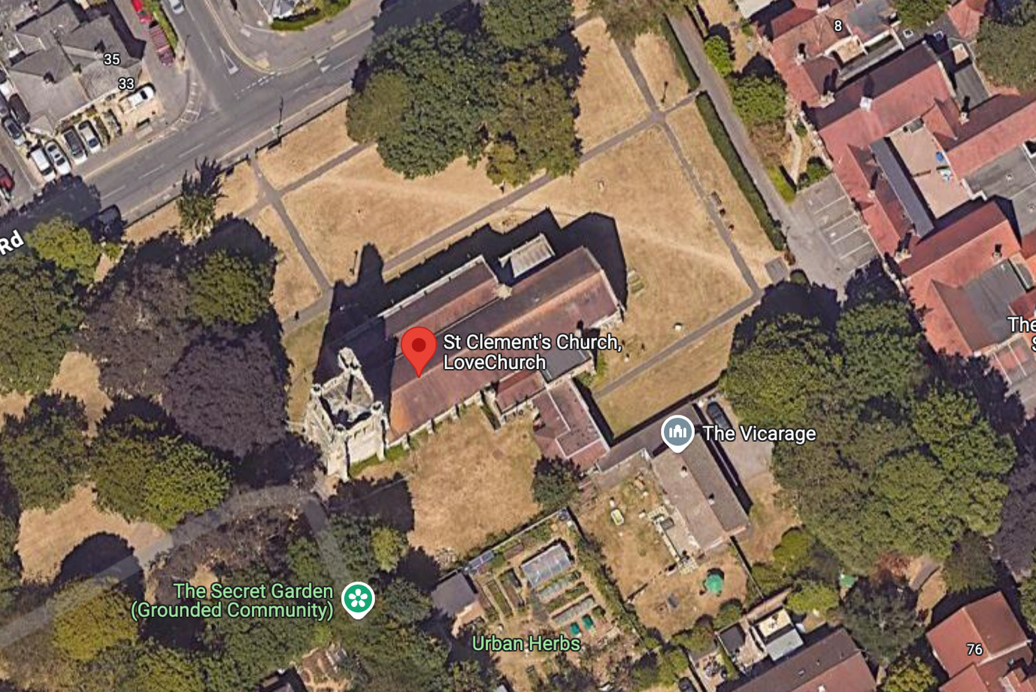

Church External

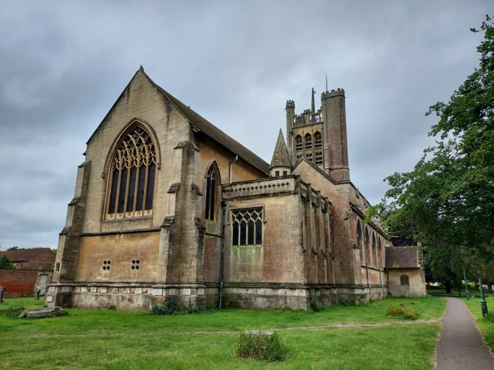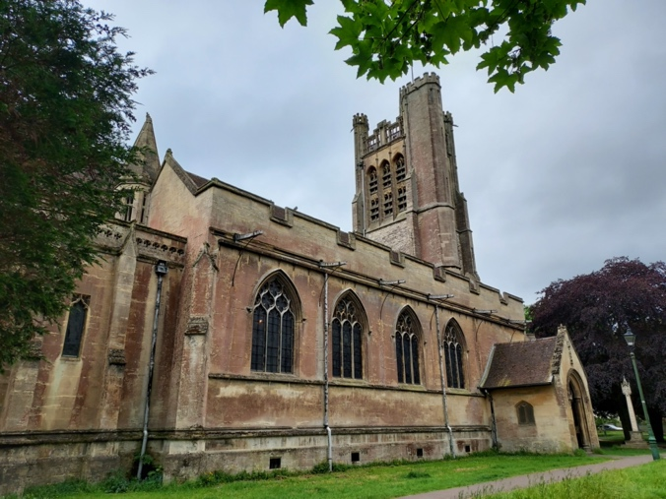

Church Plan

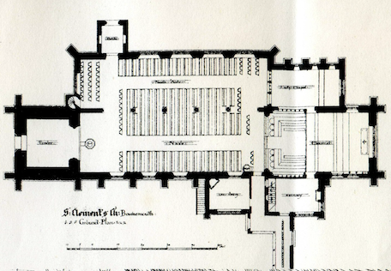
.
Demography
The parish population is 9,411, but the church draws from over 21,000 Boscombe residents because of its location. Mosaic census data (covering two wards) shows that Boscombe is young (average age 42). 18% are children under the age of 14. Almost half of the parish is under 29. Another 25% is aged 35-44. Family units are 37% of households, and 37% of all households are “Overcrowded”.

Boscombe is a very diverse community, over a third are non-UK born, with enclaves within the parish which are 53% non-UK. In our linked schools, 37 different non-English first languages are spoken in 52% of the children, and over 53% have free school meals. The ethnicity (not country of origin) breakdown shows that over 80% are white, with 10-12% of Asian, Black, or Mixed. The 47.6% UK born flagged area below is adjacent to the church and schools.

The parish ranks 6% for overall deprivation at 771 out of 12239 (Index of Multiple Deprivation 2019). Especially poor indices are employment 8%, Crime 6%, Health 8%, Children & Youth 3%.

Church Mission
We want St Clements Church to be a place of change, hope and healing for everyone. But we especially want to focus on the children and young family units in the community, many of whom are struggling with the cost of living, with language barriers, or with their circumstances.

We believe that building strong children and young people in our community, together with our diverse community can change their future, and the future of this country. To do this in a unique heritage building, in a place where history can be shared and known, identity and belonging can be shaped is a huge opportunity.

That St Clements Church:
- Is a space of grace, acceptance and hope, in and for everyone in the community
- Works strongly and positively with other agencies in partnership.
- Listens carefully - to the strengths, needs and hopes, of individuals and the community
- Has a multicultural emphasis where everyone feels welcome, and diversity is celebrated
- Responds to those appropriately by working and being with and in the community.
- Remains flexible, re-shaping its provision and use to those things that are the most needed wanted and effective in the community.
- That it always retains a strong community connection and is self-sustaining.
- That it demonstrates clear outcome and impact data for the activities it hosts, showing its effectiveness.

Community Engagement
St Clements church currently has significant community use in schools use, and in strong and active social action outreach.

