Migration Fact Sheet

Why does migration happen?
Mass migration (large-scale movements of people across regions or borders) has happened throughout human history. These migrations are driven by a complex interplay of push and pull factors, shaped by economic, political, social, environmental, and technological forces.
Those who move to live in other countries can be described as migrants or refugees:

- Migrants are those who have chosen to move to look for better employment opportunities or quality of life
- Refugees are those who are forced to move due to a threat to life, imprisonment or persecution

There are a number of reasons why people migrate or become refugees:

Summary Table
Category | Push Factors | Pull Factors
Economic | Poverty, unemployment, lack of land | Jobs, better wages, economic growth
Political/Conflict | War, persecution, instability | Peace, asylum, democracy
Environmental | Disasters, climate change | Safer, more resilient areas
Social/Cultural | Discrimination, exclusion | Family ties, cultural freedom
Technological | N/A | Easier movement, communication
Historical/Colonial | Slavery, labour migration, postcolonial ties | Familiarity, legal routes

Useful teaching resources from the UN Refugee Agency: Teaching about Refugees | UNHCR UK


1. Economic Factors
Push Factors:
- Poverty and unemployment: Lack of economic opportunities drives people to seek better livelihoods elsewhere.
- Farming collapse: Crop failures, land degradation, or overpopulation have historically forced rural populations to move.
Pull Factors:
- Employment opportunities: Industrialization attracting labourers (e.g. 19th-century Europe or modern Gulf States).
- Higher wages and better living standards: Economic growth in certain countries or regions draws migrants.

Examples
The Great Atlantic Migration (19th–20th centuries): Millions of Europeans, especially from Ireland, Italy, and Germany, migrated to the Americas seeking employment and escaping poverty.
Gulf Labour Migration (20th–21st centuries): Large numbers of South Asians migrated to Gulf countries like Saudi Arabia and the UAE for construction and service jobs during the oil boom.

2. Political and Conflict-Related Factors
Push Factors:
- Wars and civil conflict: Refugee flows during and after conflicts (e.g. Syrian civil war, World Wars).
- Persecution and oppression: Religious, ethnic, or political persecution (e.g. Jews fleeing Nazi Germany, Rohingya Muslims from Myanmar).
Pull Factors:
- Political stability: Democratic governance and rule of law attract those fleeing instability.
- Asylum policies and refugee protections: Nations with open asylum systems draw refugee populations.

Examples
Post-WWII Displacement: Millions of Europeans displaced by war and redrawing of borders.
Syrian Refugee Crisis (2011–present): The civil war has displaced over 13 million Syrians, many of whom fled to neighbouring countries and Europe.

3. Environmental and Climate Factors
Push Factors:
- Natural disasters: Earthquakes, tsunamis, droughts, floods (e.g. Bangladesh floods, Haiti earthquake).
- Climate change: Desertification, sea-level rise, and extreme weather drive "climate refugees."
Pull Factors:
Safer environments: Regions less affected by environmental hazards become migration magnets.
Dust Bowl Migration (1930s, USA): Severe dust storms and drought forced many farming families from Oklahoma and nearby states to move to California.
Bangladeshi Migration due to Flooding (20th–21st centuries): Recurrent flooding and rising sea levels have led to internal and cross-border displacement.

4. Social and Cultural Factors
Push Factors:
- Discrimination: Ethnic, gender, or caste discrimination can lead to social exclusion and forced migration.
- Cultural marginalization: Loss of cultural autonomy or identity.
Pull Factors:
- Diaspora communities: Migrants often follow social networks to join family or cultural groups abroad.
- Freedom and tolerance: Open societies attract individuals facing social restrictions.
Jewish Migration to Israel (Post-1948): Driven by religious and cultural ties, Jews from around the world migrated to the newly established state of Israel.
Indian Migration to the UK (1950s–1970s): Many Indians moved to Britain seeking better educational and professional opportunities and to join family already settled there.


5. Technological and Infrastructural Change
Push Factors: None
Pull Factors:
- Transportation advances: Railways, steamships, and later air travel enabled larger and faster migrations.
- Communication technologies: Knowledge about opportunities abroad spreads more easily today.
- Border enforcement and surveillance: Can either impede or facilitate mass movements depending on policies.
Examples
Large-scale migration of Indian IT professionals to the U.S. via H-1B visas.
Advances in air and sea transport after World War II (e.g., steamships, commercial aviation) making it easier and more affordable to travel longer distances.


6. Historical and Colonial Legacies
Push Factors:
- Enslavement: Peoples transported for forced labour as part of the slave trade.
Pull Factors:
- Economic opportunity: Movement of people post-independence back to origin of colonial power.

Examples
An example of forced slave trade migration is the Transatlantic Slave Trade (16th to 19th centuries). Between the 1500s and 1800s, over 12 million Africans were forcibly taken from West and Central Africa and transported across the Atlantic Ocean to the Americas. Brazil received the largest number of enslaved Africans.
The Caribbean and Southern United States are also places where enslaved people formed the backbone of colonial economies.
Postcolonial migration: Former colonial subjects moving to the original country of power (e.g. Indians to the UK, Algerians to France).
In 1948, the ship HMT Empire Windrush brought hundreds of Caribbean migrants to Britain.

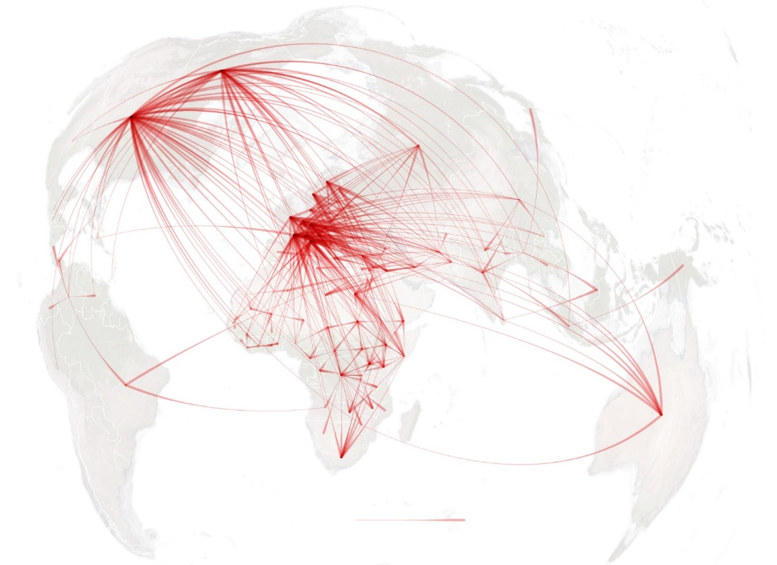
A Map Showing Migrations of Peoples Throughout History:

