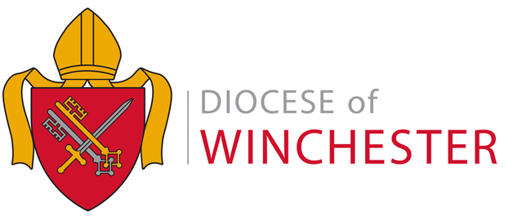



Associate Minister – Focal Minister for West Andover & Lead for Ministry and Leadership Development

A dynamic pastor and priest with a heart for mission and people.

Andover Parish is entering an exciting new season under a recently appointed Rector, uniting four churches around one shared mission and the values of Word, Spirit, and Sacrament.

We seek an Associate Minister to provide pastoral leadership at St Michael’s, West Andover, and to develop ministries and leadership across the four churches (parish population 53,000). You’ll lead a warm, Eucharistic congregation committed to hospitality and creative mission, and in time, plant a new family-focused congregation.

Parish-wide, you’ll help develop lay ministries and shape leadership pathways with safeguarding excellence as
we grow and plant new congregations.

You’ll join a collaborative team who pray, plan, and laugh together — a a zeal for mission.

We’re looking for someone who:
• Is a priest of the Church of England, confident in Word, Spirit, and Sacrament
• Combines a pastoral heart with strategic vision and missional drive
• Loves to see others grow in faith, service, and leadership
• Brings emotional intelligence, humour, and courage

Informal conversation: Revd Dr Peter Harwood, Rector — rector@andoverparish.org

Closing date: 13 November at noon
Interviews: 3-4 December 2025

Application pack available
Apply Here

An enhanced DBS check is required

