Night Prayer
(Compline)
Winchester Diocese
Clergy Conference
2026

An Order for Night Pryer
(Compline) in Traditional Language

The ancient office of Compline derives its name from a Latin word meaning ‘completion’ (completorium). It is above all a service of quietness and reflection before rest at the end of the day. it is most effective when the ending is indeed an ending, without additions, conversations or noise.

We remain seated throughout.
At its end, those present depart in silence.

ORDER OF SERVICE
Preparation

The Lord almighty grant us a quiet night and a perfect end.
All Amen.

Be sober, be vigilant; because your adversary the devil, as a roaring lion, walketh about, seeking whom he may devour: whom resist, steadfast in the faith.
(1 Peter 5.8,9)

But thou, O Lord, have mercy upon us.
All Thanks be to God.
Our help is in the name of the Lord;
All who hath made heaven and earth.

A period of silence for reflection on the past day may follow.
The following or other suitable words of penitence may be used.

All We confess to God almighty, the Father, the Son and the Holy Ghost,
that we have sinned in thought, word and deed, through our own grievous fault. Wherefore we pray God to have mercy upon us.

Almighty God, have mercy upon us,
forgive us all our sins and deliver us from all evil,
confirm and strengthen us in all goodness,
and bring us to life everlasting; through Jesus Christ our Lord.
Amen.

A priest says
May the almighty and merciful Lord grant unto you pardon and remission of all your sins, time for amendment of life, and the grace and comfort of the Holy Spirit.
All Amen.

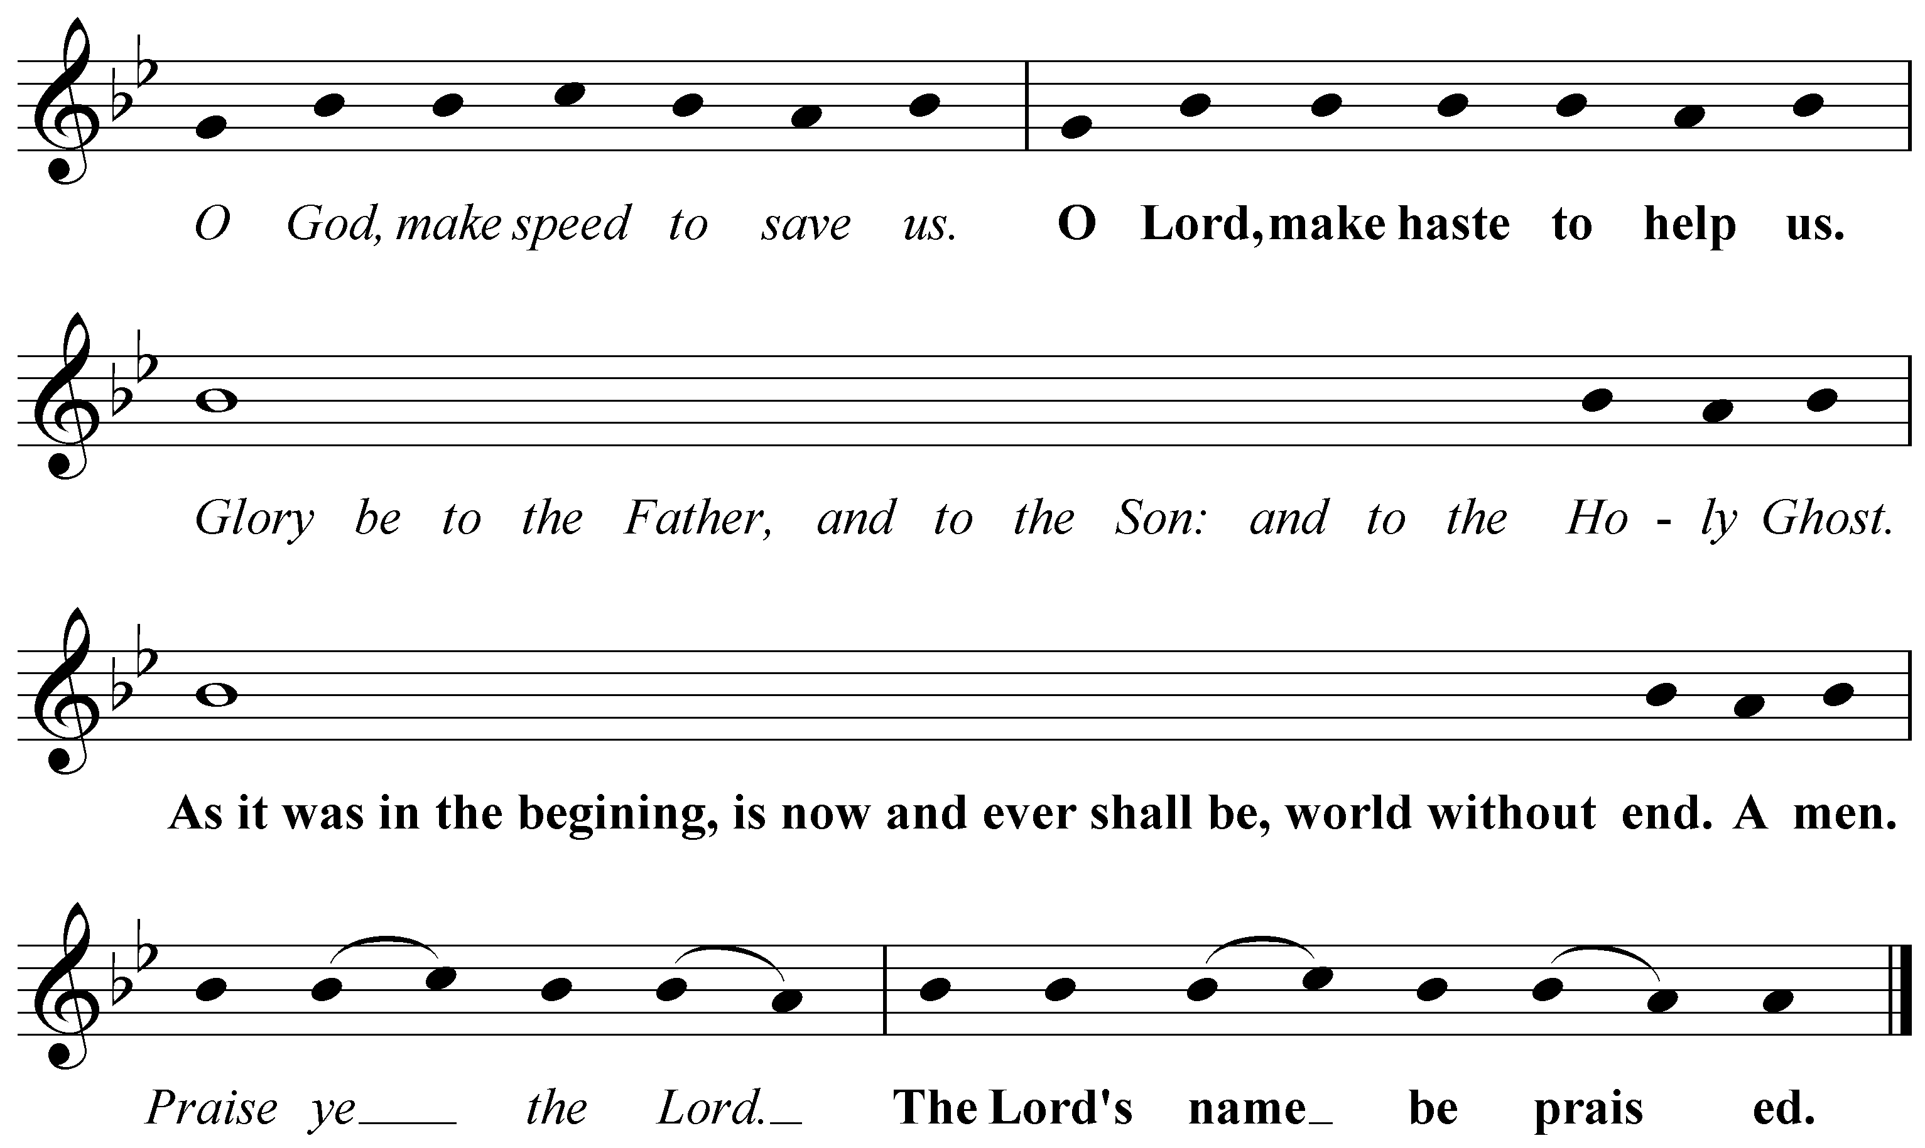

The following or another suitable hymn may be sung
Ferial



1
Before the ending of the day,
Creator of the world we pray,
That with thy wonted favour thou
Wouldst be our guard and keeper now.
2
From all ill dreams defend our eyes,
From nightly fears and fantasies;
Tread underfoot our ghostly foe,
That no pollution we may know
3
O Father, that we ask be done,
Through Jesus Christ, thine only Son;
Who, with the Holy Ghost and thee,
Doth live and reign eternally.

The Word of God
Psalmody
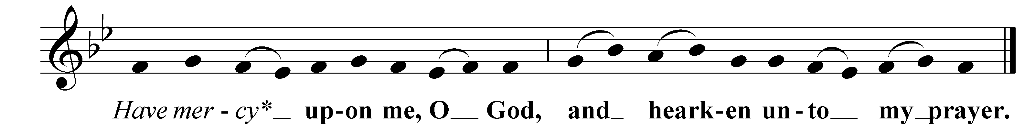
Psalm 4 with the Antiphon



- Hear me when I call, O God of my righteousness:
thou hast set me at liberty when I was in trouble;
have mercy upon me, and hearken unto my prayer.

- O ye sons of men, how long will ye blaspheme mine honour:
and have such pleasure in vanity, and seek after leasing?

- Know this also, that the Lord hath chosen to himself
the man that is godly:
when I call upon the Lord, he will hear me.

- Stand in awe and sin not:
commune with your own heart, and in your chamber, and be still.

- Offer the sacrifice of righteousness:
and put your trust in the Lord.

- There be many that say:
Who will shew us any good?

- Lord, lift thou up:
the light of thy countenance upon us.

- Thou hast put gladness in my heart:
since the time that their corn, and wine, and oil increased.

- I will lay me down in peace, and take my rest:
for it is thou, Lord, only, that makest me dwell in safety.

Glory be to the Father, and to the Son:
and to the Holy Ghost;
As it was in the beginning, is now and ever shall be:
world without end.
Amen.

Scripture Reading

One of the following short lessons or another suitable passage is read

Thou, O Lord, art in the midst of us, and we are called by thy name;
leave us not, O Lord our God.
Jeremiah 14:9

Come unto me, all ye that labour and are heavy laden, and I will give you rest. Take my yoke upon you, and learn of me; for I am meek and lowly in heart: and ye shall find rest unto your souls. For my yoke is easy, and my burden is light.
Matthew 11:28-30

Now the God of peace, that brought again from the dead our Lord Jesus, that great shepherd of the sheep, through the blood of the everlasting covenant, make you perfect in every good work to do his will, working in you that which is well-pleasing in his sight; through Jesus Christ, to whom be glory for ever and ever. Amen.
Hebrews 13:20,21
All: Thanks be to God.

A period of silence for reflection on the Word may follow.

The Responsory
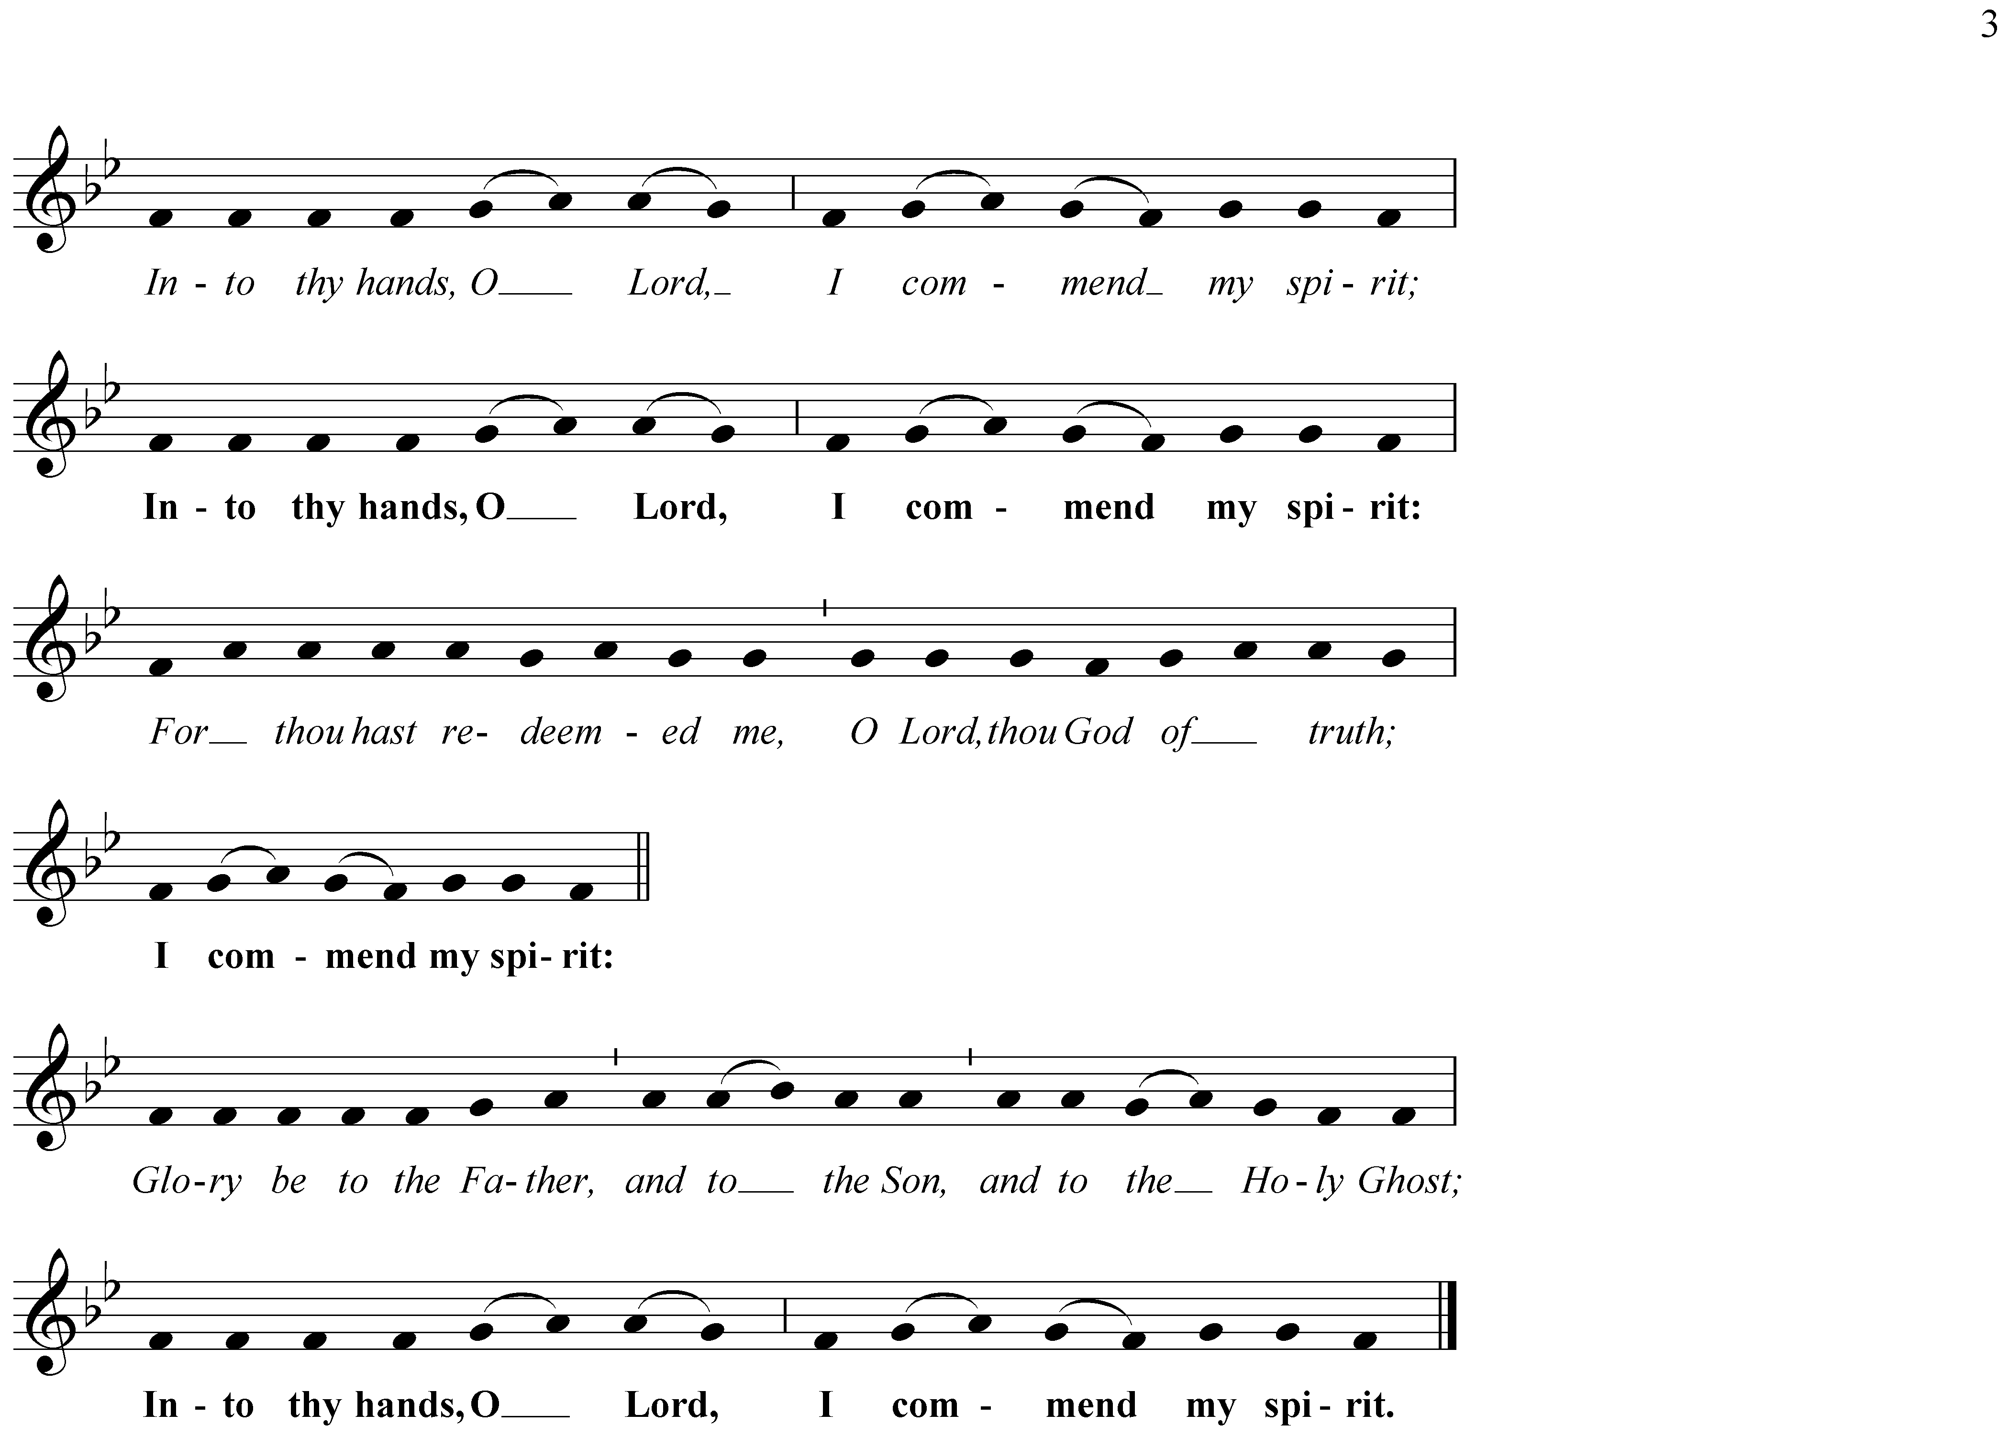

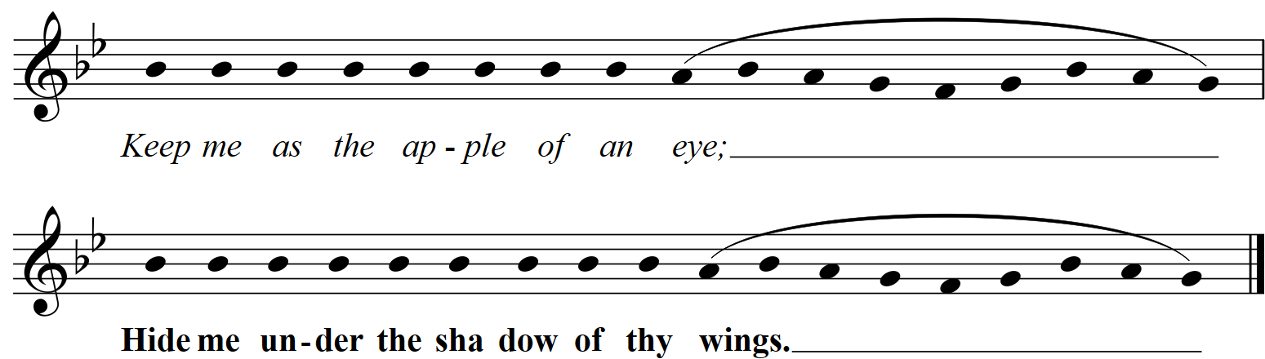

Gospel Canticle

The Nunc dimittis (The Song of Simeon) is sung preceded by this Antiphon
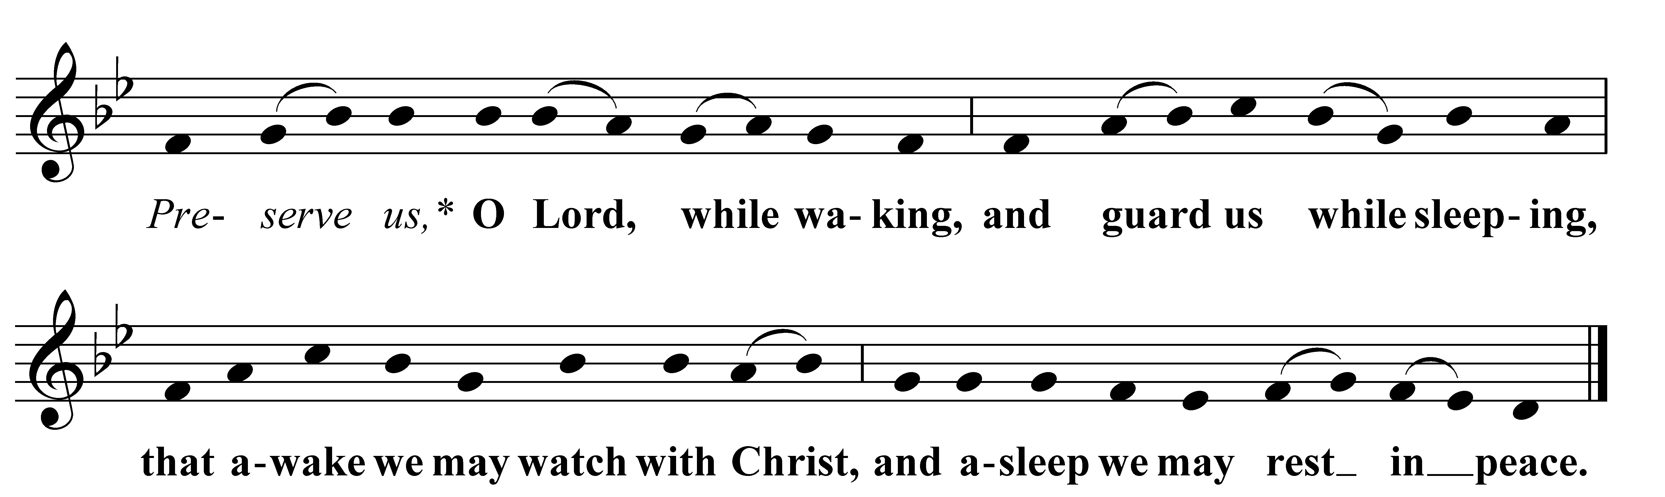

- Lord, now lettest thou thy servant depart in peace:
according to thy word.

- For mine eyes have seen:
thy salvation;

- Which thou hast prepared:
before the face of all people;

- To be a light to lighten the Gentiles:
and to be the glory of thy people Israel.
Luke 2:29-32
Glory be to the Father, and to the Son:
and to the Holy Ghost;
as it was in the beginning, is now, and ever shall be:
world without end. Amen.

Prayers
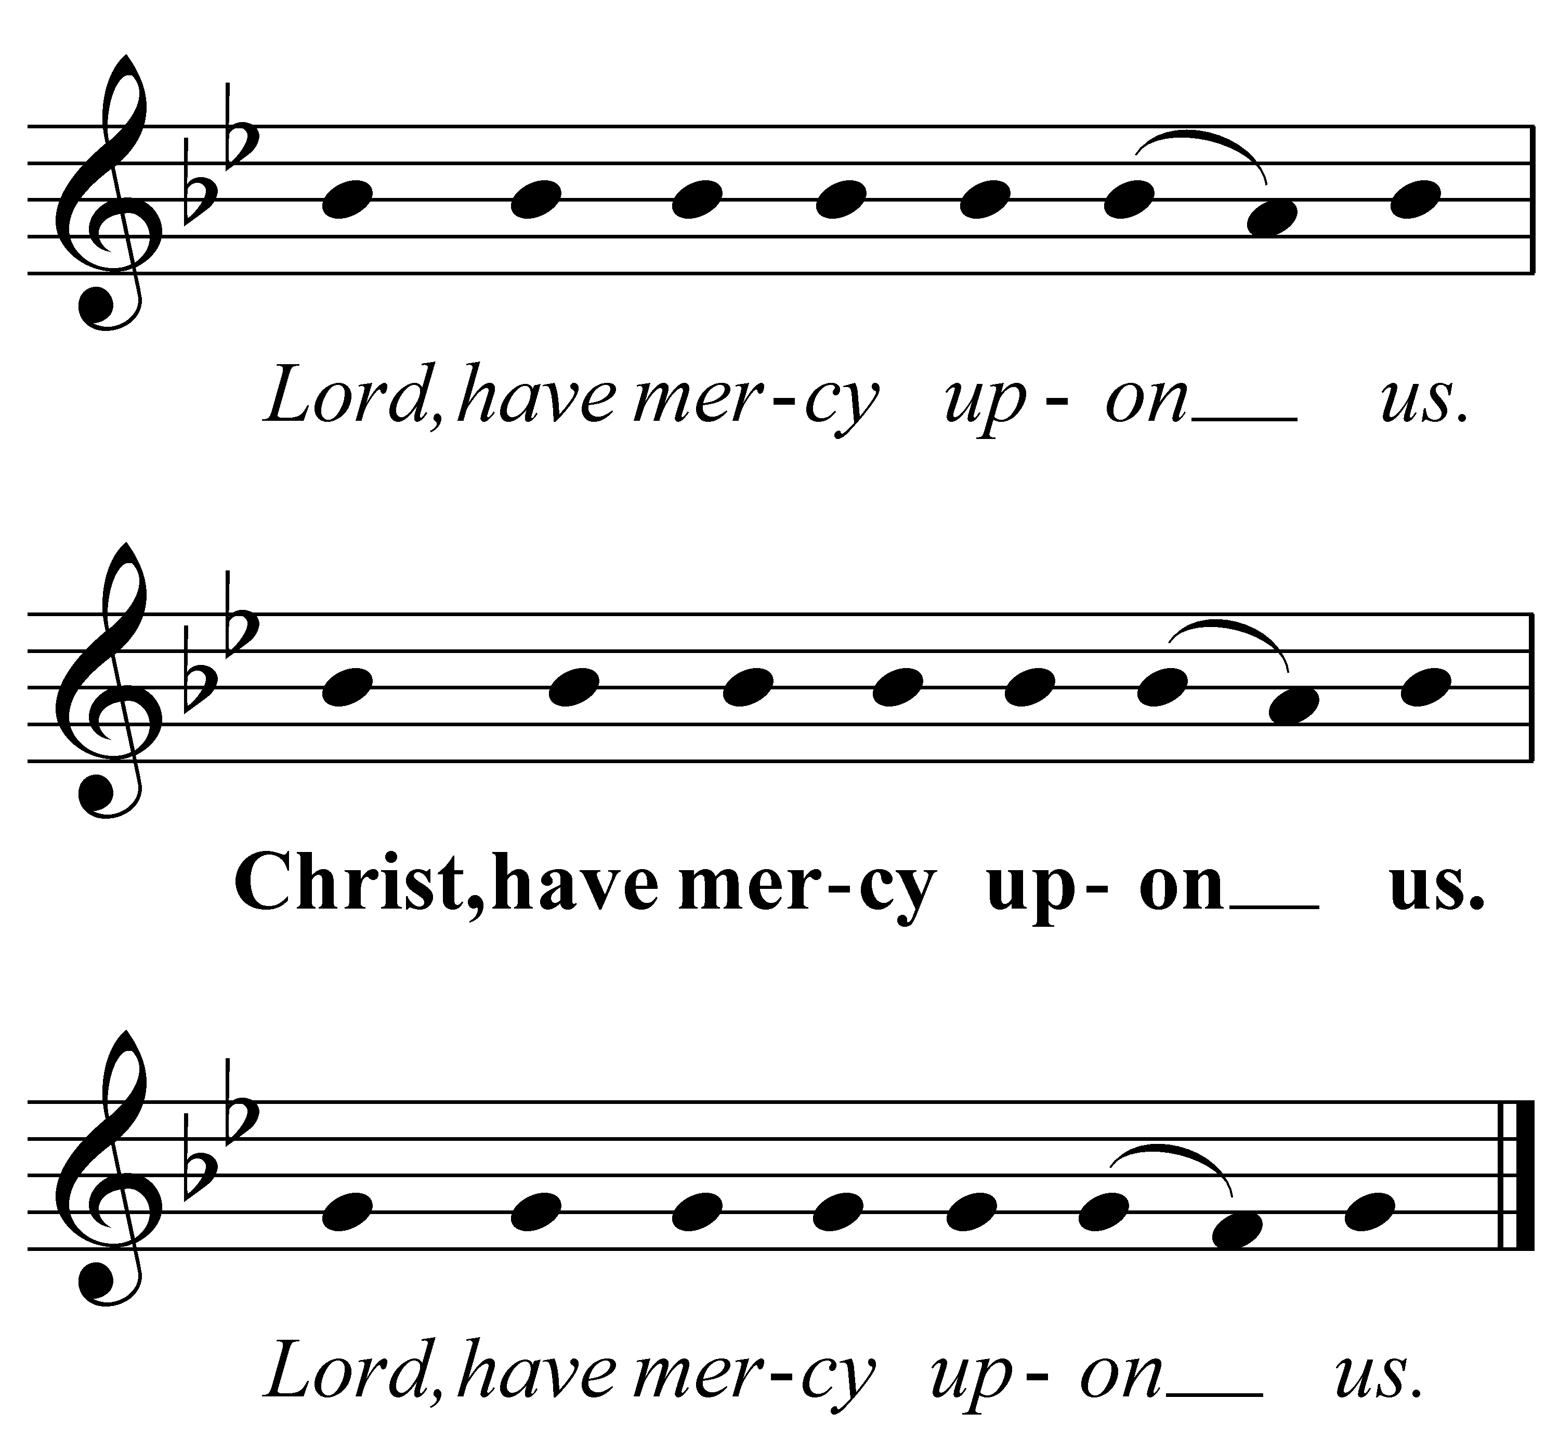

All: Our Father, which art in heaven,
hallowed be thy name;
thy kingdom come;
thy will be done,
in earth as it is in heaven.
Give us this day our daily bread.
And forgive them that trespass against us.
And lead us not into temptation;
but deliver us from evil.
Amen.

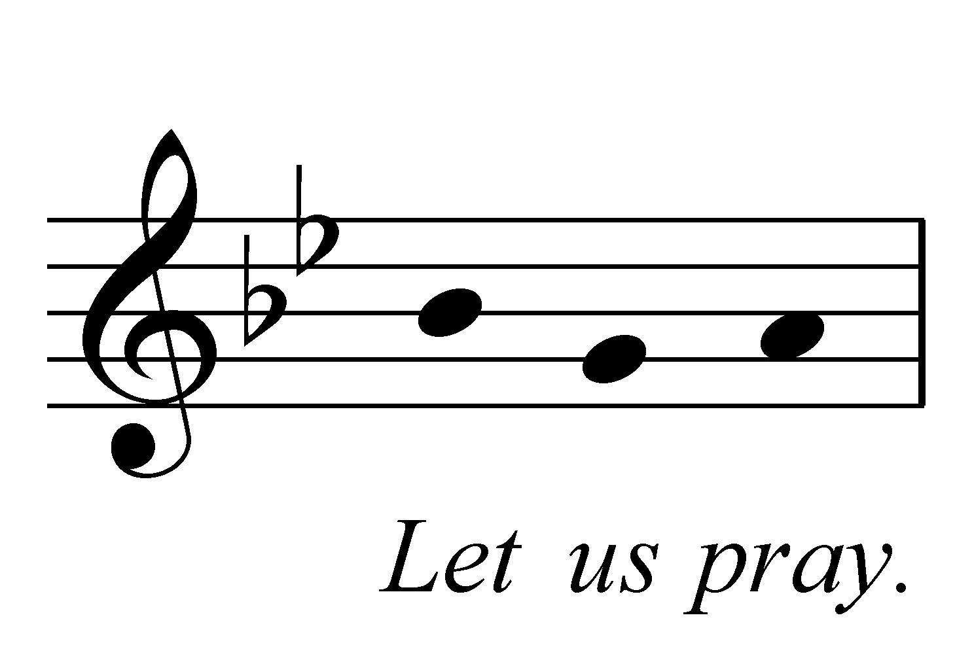

One or more of the following Collects is said

Visit, we beseech thee, O Lord, this place,
and drive from it all the snares of the enemy;
let thy holy angels dwell herein to preserve us in peace;
and may thy blessing be upon us evermore;
through Jesus Christ our Lord.
All: Amen.

Lighten our darkness, we beseech thee, O Lord;
and by thy great mercy defend us from all perils and dangers of this night;
for the love of thy only Son, our Saviour, Jesus Christ.
All: Amen.

O Lord Jesus Christ, son of the living God,
who at this evening hour didst rest in the sepulchre,
and didst thereby sanctify the grave to be a bed of hope to thy people:
make us so to abound in sorrow for our sins, which were the cause of thy passion,
that when our bodies lie in the dust, our souls may live with thee;
who livest and reignest with the Father and the Holy Ghost,
one God, world without end.
All Amen.

Look down, O Lord, from thy heavenly throne,
illuminate the darkness of this night with thy celestial brightness,
and from the sons of light banish the deeds of darkness;
through Jesus Christ our Lord.
All Amen.

Be present, O merciful God, and protect us through the silent hours of this night,
so that we who are wearied by the changes and chances of this fleeting world,
may repose upon thy eternal changelessness;
through Jesus Christ our Lord.
All Amen.

A period of silence for reflection may follow.

The Conclusion
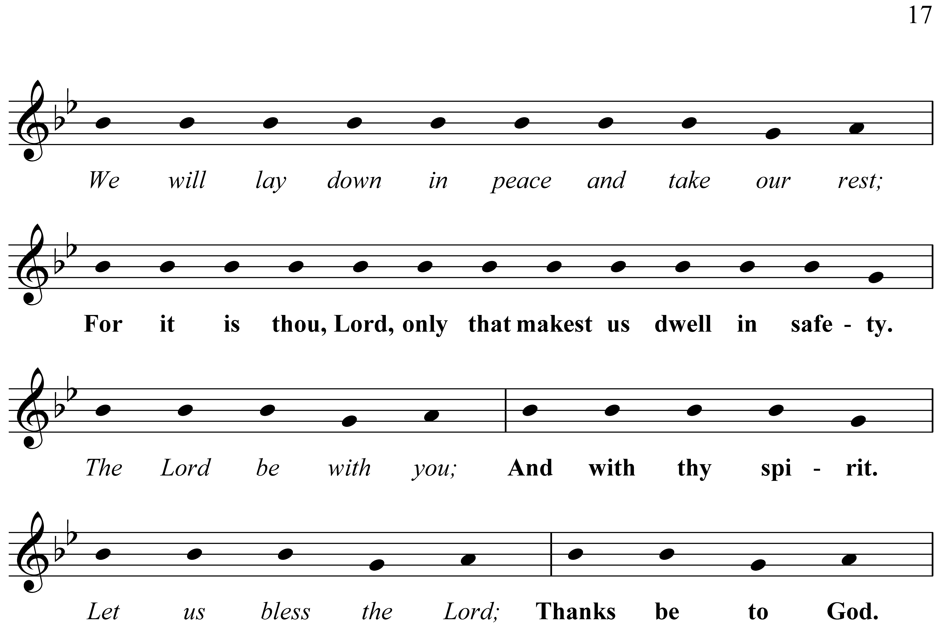

The almighty and merciful Lord, the Father, the Son and the Holy Ghost,
bless us and preserve us.
All: Amen.
Please depart in silence

Material used in this service is copyright ©
the Archbishops’ Council of the Church of England 2000
Music notation from Winchester Cathedral Order of Compline 2020 – used with permission

